Disclosure Request Report

Prepared by: | Molly Haley
Submitted for: | Approval
Decision details: | CoMC is requested to approve this request to release data items to the RPA
Date | 7th December 2023
DRR Reference | DRR-Dec23-01

RPA Report Amendment
- Introduction and background
For the interest of the committee, we are providing some background on this request to show the existing data items in the current report, the ones which are being removed (strikethroughs) and the ones which are being added (in bold). 3 of the 5 data items that are being added to the report are already approved on the DPM for release to RECCo. Section 2 lists the remaining 2 data items which are being requested to be released to RECCo in the DMP.
The CDSP currently provides a suite of reports to the REC Performance Assurance Code Manager (RPA) as defined in the CDSP Further Services Service Definition in the Retail Energy Code. These reports are provided monthly to RPA to support the REC Performance Assurance Board. The RPA have requested that an existing report is amended to remove some data items, and provide further data items so that they can monitor the recording of Meter Asset Provider Market (MAP) Participant Identities (MPId). They also propose to investigate this by Supply Meter Point AQ range, and Market Sector.
This would result in a report with the following fields (note: the removed fields are shown as struck through; and the new fields to be added to this report are bold):
- Meter Point Reference Number
- Meter Serial Number
- Current Supplier
- Current Supplier EFD
- Meter Mechanism
- Meter Type
- Meter Installation Date
- Meter Capacity
- Meter Model
- Meter Year of Manufacture
- Number of Dials
- Imperial Indicator
- Reading Factor
- Pulse Value
- Meter Point Status
- Meter Point Status Effective Date
- Meter Asset Manager
- Meter Asset Manager Effective Date
- Meter Asset Provider
- Meter Asset Provider Effective Date
- Meter Status
- Meter Status Effective Date
- Supply Meter Point Market Sector Code
- Supply Meter Point AQ

The report is currently provided by the CDSP to RECCo as a CDSP Third Party Service. Consistent with these services these are recorded in the Data Permissions Matrix against RECCo (rather than explicitly against the Code Manager). As a consequence, RECCo need to be recorded on the DPM as having permission to receive the following additional data items:

- Meter Asset Provider
- Meter Asset Provider Effective Date

Meter Asset Manager Effective Date; Supply Meter Point AQ and Market Sector Code are currently available to RECCo so do not need to be added.
The data items that no longer appear in this report, are not intended to be removed from the RECCo column of the DPM since other reports contain these data types (i.e. Metering Detail) which is data that is mastered under the Retail Energy Code.
We do not believe this DRR requires any change to the DPM Conditionality Document as it does not involve the release of data to a new User type or introduce any new conditions.

An updated version of the DPM is attached as an appendix to this document.

- Data items
This DRR is to request the release of:
- Current MAP Short Code (or where displayed as Name, the Current MAP Organisation Name)
- Current MAP EFD

- Privacy Impact Assessment
Where the disclosure of information includes the processing of personal data a Privacy Impact Assessment may be required.
Xoserve has considered the various tests that may be applied and considers that none of these are met and so a Privacy Impact Assessment is not required.
The tests (and answers) applied in determining whether a Privacy Impact Assessment was required were:
a) Will the project involve the collection of new information about individuals?
No, this is existing data which is already available in Xoserve systems.
b) Will the project compel individuals to provide information about them?
No, the data is already used part of existing processes.
c) Will information about individuals be disclosed to organisations or people who have not previously had routine access to the information?
No, this data does not include information about an individual that the Registered User cannot already access.
d) Are you using information about individuals for a purpose it is not currently used for, or in a way it is not currently used?
No.
e) Does the project involve you using new technology that might be perceived as being privacy intrusive? For example, the use of biometrics or facial recognition.
No.
f) Will the project result in you making decisions or acting against individuals in ways that can have a significant impact on them?
No.
g) Is the information about individuals of a kind particularly likely to raise privacy concerns or expectations? For example, health records, criminal records or other information that people would consider to be private.
No.
h) Will the project require you to contact individuals in ways that they may find intrusive?
No, there is no requirement to contact individuals.
i) Will the disclosure of information utilise new technology for Xoserve?
No. It is expected that this data will be SFTPd to RECCo.
j) Will the disclosure include information that identifies a vulnerable customer?
No.
k) Will the disclosure release mass data to a party?
No.
l) Will the disclosure include information that identifies an occurrence of theft of gas?
No.
m) Will the disclosure require a fundamental change to Xoserve Business?
No.

- Commercial model
It is proposed that the reporting will be provided in accordance with the DSC Third Party and Additional Services Policy.

- Method of access to the dataset
Access to the dataset will be provided by sending reports to RPA via SFTP
- CoMC determinations
CoMC is requested to approve this Disclosure Request Report.

Appendix 1: Current Data Permissions Matrix with proposed changes as per this Disclosure Request Report
Please see attached the proposed changed to the Data Permissions Matrix as a result of approving this DRR. Changes/additions are marked up in red text.
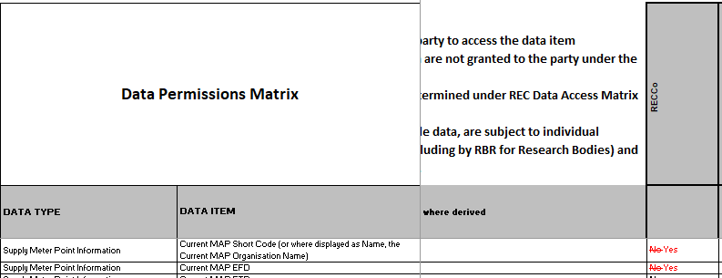
This is proposed to be published as v23 of the DPM, subject to CoMC approval.

Appendix 2: Current DPM – Conditionality Document

We do not believe this DRR requires any change to the DPM Conditionality Document as it does not involve the release of data to a new User type or introduce any new conditions.

