Uniform Network Code Committee
Performance Assurance Committee Terms of Reference

- Introduction

The Uniform Network Code Committee (UNCC) originally agreed these terms of reference for the Performance Assurance Committee (PAC) in 2018 and amendments shall only be made with the consent of the UNCC.

- Scope of the PAC

  - General

The PAC is defined as a sub-committee of the Uniform Network Code Committee, with certain rights and responsibilities relating to the management of the community’s Performance Assurance Framework (PAF).

The PAC is chaired by the Joint Office and is attended by PAC Members and an Ofgem representative. From time to time, the PAC may invite other individuals to attend, in a non-voting capacity. In respect of any such individual, the PAC may, from time to time, determine that such individual be excluded for all or part of the meeting of the PAC. Ofgem shall be entitled to send a nominated representative to the meeting, who (for the avoidance of doubt) will attend in a non-voting capacity and shall be not be excluded from any part of the meeting.

The PAC and any Performance Assurance Framework is limited to energy and supply points within local distribution zones, it does not extend to energy transported through the National Transmission System and supply meter points connected to it.

  - Performance Assurance Committee structure

The PAC comprises of a Shipper and Transporter constituency. The Shipper constituency comprises of 9 Shipper User Members, all of whom have voting rights (as determined by the annual User Representative process) and the Transporter constituency comprises of 3 Transporter-appointed Members (comprising 2 large distribution Transporters and 1 INA nominee), all of whom have voting rights. NTS will not have membership rights.

Ofgem will have the right to provide a PAC representative, at their own discretion, who will be in an advisory capacity only. Ofgem shall advise the Joint Office of their nominated representative on an annual basis or less frequently in the event of no change to the representative. For the avoidance of doubt, the Ofgem representative is not a PAC Member.

Shipper PAC Members are appointed for a period of two Gas Years commencing on the 1st October and at other times when vacancies occur. These appointments will be conducted by the Designated Person.

Each Shipper PAC Member shall serve for a term which lasts for a period of two Gas Years. In order to avoid loss of continuity, each year the Designated Person will conduct elections for the required number of Shipper PAC Member positions set out in these Terms of Reference such that each appointment lasts for 2 Gas Years.

Transition to staggered Shipper PAC Membership
In the first Gas Year in which the appointments fall for the transition to a 2 Gas Year appointment term, (nominations late in Gas Year 2022/23) 5 PAC Shipper Members (selected at random by the Designated Person) out of 9 PAC Shipper Members will be elected to serve for an appointment term of two Gas Years from 01 October 2023, the other four will be appointed to serve for one Gas Year from 01 October 2023. Thus for appointments occurring late in Gas Year 2023/24 the other four PAC Shipper Members will move to a 2 Gas Year appointment term from 01 October 2024. In this way from 01 October 2024 all Shipper PAC Members will be serving a two Gas Year appointment term but ending in alternate Gas Years to avoid the risk of a loss of continuity.

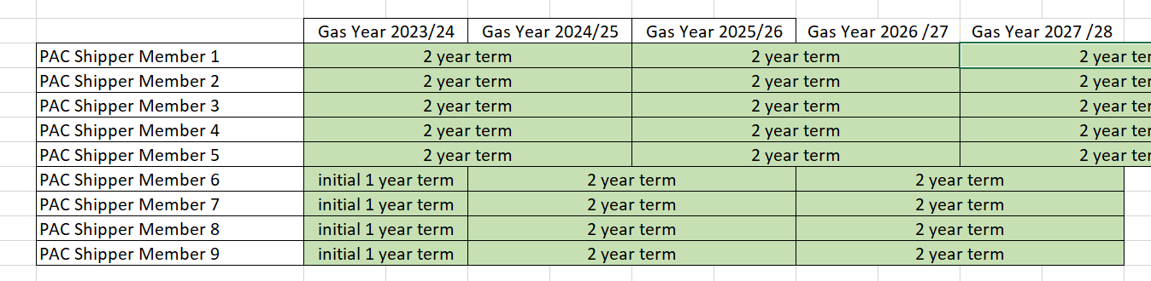
Figure 1: Introduction of two Gas Year appointment term to avoid loss of continuity

PAC Members are representatives in their own right and do not represent the company by which they are employed. The Designated Person election rules permit no more than one Shipper User PAC Member per company and it will be for the nominating Party to consider the suitability of their nominee, in respect of experience and understanding of the issues that the PAC will deal with.

All PAC Members and their alternates will be required to sign a Confidentiality Assurance Document and their employer (or Nominating Party in the event of persons not employed by a User) shall also be required to sign an Employer Assurance Document (Nominating Party Assurance Document) to assure that the Member will be attending and voting at the PAC in the interests of the GB gas industry and not representing any commercial interest or commercial body.

A list of all PAC Members and their appointment terms and standing alternates is published on the Joint Office website.

A PAC Member may appoint an alternate either on a standing basis or on a meeting-by-meeting basis. Such appointments shall be made in writing or by email to enquiries@gasgovernance.co.uk . Alternates need not necessarily come from the same company as the PAC Member. It will be for the PAC Member to consider the suitability of their alternate, in respect of experience and understanding of the issues that the PAC will deal with. A single alternate may represent more than one (1) PAC Member.

Non-Members will only be permitted to attend non-confidential sessions of the PAC.

The CDSP and the Performance Assurance Framework Administrator (PAFA) will send appropriate representatives to the meeting.

  - Meetings

The PAC endeavours to meet on a monthly basis. The meeting will be quorate where there are at least four Shipper User PAC Members and two Transporters (DNO and/or IGT) PAC Members with a minimum of six PAC Members in attendance.

The Code Administration Code of Practice shall apply to the conduct of the meetings.

The PAC may decide to meet more or less frequently as required.

Information to be used within meetings will be provided to PAC Members, the Joint Office and the Ofgem representative via a secure web portal. Such information shall not be downloaded by the Ofgem representative and all PAC Members, the Joint Office and Ofgem shall treat all information as confidential unless it is clearly marked otherwise.

The default is PAC meetings are ‘closed’ to non-Members. PAC Members can agree to hold ‘open’ meetings.

With agreement of the Chairperson, and for the purposes of developing the PAC arrangements, PAC Members can invite 3rd parties and non-members to the meeting.

To facilitate training, Alternate PAC Members who have signed all required confidentiality documents, may attend meetings to observe in a non-voting capacity, including the closed part of the meeting. To facilitate this, the PAC Member shall inform the Chair in advance in writing or by email to enquiries@gasgovernance.co.uk.

  - Decision making
Where the meeting is quorate, all decisions shall be made by simple majority of PAC Members or their nominated alternate in both Shipper and Transporter constituencies. PAC Members may vote for or against a proposal, any abstention shall not count towards the simple majority count. Where such agreement is not obtained, the Chairperson shall submit the matter to the Uniform Network Code Committee for consideration.

  - Roles and responsibilities of Performance Assurance Committee

The PAC is responsible for:
- overseeing the work of the Performance Assurance Framework Administrator;
- overseeing the PAF Risk Register;
- determining reporting and analysis to inform a reliable assessment of the performance of gas settlement;
- reviewing relevant settlement performance data; and,
- where settlement performance deficiencies are identified, proposing (and, where within the PAC’s control, implementing) methods of resolution to improve settlement performance.

The PAC shall perform the duties ascribed to it in the “Performance Assurance Framework Document for the (Gas) Energy Settlement Performance Assurance Scheme”.

Document Control
Version Number | Status | Date | Reason For Change
5.1 | Draft | 10 August 2022 | Possible introduction of 2 year appointment term
5.0 | Final | 14 December 2020 | Annual Review

