DSC Business Evaluation Report (BER)

Change Title | Implementation of Resend Functionality for Messages from CSS to GRDA (REC CP R0067)
Xoserve reference number (XRN) | XRN5567
Correla Project Manager | TBC
Email address
Contact number
Target Change Management Committee date | January 2023
Section 1: In Scope
This change request proposes the ability for Central Service Providers to request CSS to issue specific messages. This change is seen as one of a number of mitigations to reduce the likelihood of inconsistencies between the CSS and other industry systems. The messages within scope of the change are:
‘Re-send’ – RegistrationSecuredActiveSynchronisation
‘Re-send’ – RegistrationCancelledSynchronisation
‘Refresh’ – RegistrationEventSynchronisation
All messages will be requested by the GRDA using predefined formats to the CSS.
The ‘Re-send’ messages will, where fulfilled, be processed within the Gate Closure period and should therefore avoid an instance of a Registration becoming effective on CSS but not being recorded on the UK Link system. The Re-send functionality is designed to replay the original message. Of the missed messages to date there are a number of instances where CSS did not generate the messages and so they would not be available to be sent in future. This risk should be recognised but it is hoped that such instances should be reduced as the CSS becomes more operationally mature.
The Refresh message will have to be triggered manually as an exception – for example where a Re-send request has not been fulfilled in Gate Closure, in this instance the GRDA will need to request a Refresh to determine whether CSS has set a Registration Live. The GRDA will only be able to do so once the Registration has gone live – therefore there will be an inconsistency between CSS and UKL as we will need to prospectively apply such Registrations into UK Link systems. The Refresh functionality should minimise the period of his inconsistency as it eliminates the reliance on responses from the Switching Operator Service Management Incident tickets.

XRN | Title | Type | Description | Link to Change Proposal | Impacts
5567 |  | CP | Implementation of Resend Functionality for Messages from CSS to GRDA (REC CP R0067) |  | Shippers

Shippers are listed as ‘impacted’ as this Change Proposal is planned to be funded 100% by Shippers from Service Area 1. There should be no functional changes to any DSC party systems as a result of this change as the interfaces that are being changed are between the CSS and GRDA. No UK Link Communications will be amended as a result of this Change.
We have planned for a period of testing with CSS in order to ensure that CSS and GRDA/CDSP systems can integrate effectively. There is no planned external User testing.

Section 2: Out of Scope
The scope of XRN5567 is limited to the GRDA request of, and subsequent receipt of, the above three messages.

XRN5535 will be responsible for the necessary system and process changes to apply Registrations and any subsequent adjustments in instances where the CSS and UKL Effective Dates are not aligned.
Section 3: Funding required to deliver the change
The following section outlines the proposed costs

XRN Ref | HLSO £ | Design EQR | Build £ | Test £ | Implement-ation PIS £ | MT £ | 1st Year MTB £ | Delivery Total | CSSC Impact £ | Risk Margin £ | BER Total for Approval £ | Shipper £ | DN £ | IGT £ | NTS £ | Total
5567 |  |  | £24,000 | £47,275 |  |  | £22,000 | £93,275 | N/A | Nil | £93,275 | £93,275 | 0 | 0 | 0 | £93,275

CDSP had anticipated that this change R0067 was due to be implemented in the Early Life Support phase following CSS Implementation, but this approach was rejected by Ofgem. The CSSC Programme undertook a number of design and build activities in order to reduce costs and timescales for delivery of this change.

Key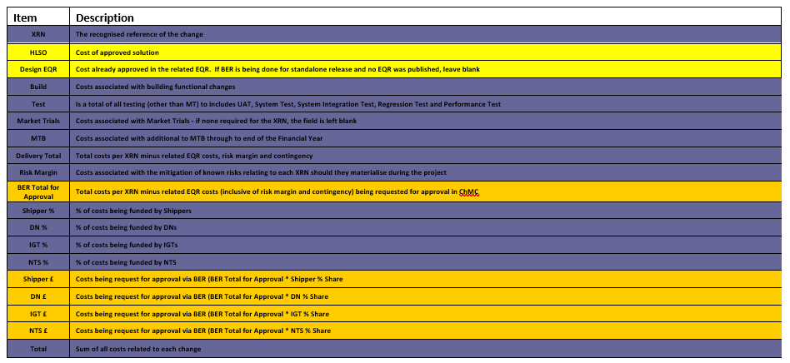
Section 4: Estimated impact of the service change on service charges
This change delivery will require additional technical components in order to request the message Resends and consequently technical support team monitoring and support. The Refresh functionality will require technical support which has been accounted for, but further requires Business Operation support which should be considered as a temporary activity until such time as the integration of the two systems are effective. This BER does not include the Operational team effort, but proposes that this is considered as part of XRN5535 – which will consider the remedial action needed for missing messages that have occurred and the necessary process changes in the event that instances occur in the future.

This Change Proposal does not propose a new DSC Service Line. It will supplement existing DSC Service Lines associated with the receipt and processing of Definitive Registration Notifications from CSS.

XRN | Xoserve Service Area & Line | Impact | (+/-) Projected Change in Annual Cost
XRN5567 | Service area 1: Manage Shipper Transfers  DS-CS SA1 – 41; DS-CS SA1 – 42 | Technical Operations additional Monitoring | + £22,000
Total |  |  | £22,000

Section 5: Project plan for delivery of the change
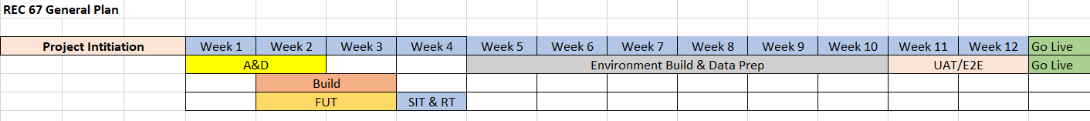

Dependencies:
- This BER is presented to ChMC prior to the approval of R0067 by the REC Change Panel. We will not progress design and build activities until R0067 is approved. Following approval by ChMC we will commence Project Initiation – e.g. identification of the project team and commencing detailed planning.
- Integration between other parties has not been undertaken. Should there be an amendment to the critical path period between the period of integration testing between the GRDS and CSS and the date of implementation this may extend the project timelines and costs quoted.

Section 6: Additional information relevant to the proposed service change
Risks:
Xoserve and Correla have yet to receive detailed technical documentation from Landmark related to the technical solution. This risk is expected to be minimal as we understand that Landmark are undertaking minimal development activity and are only extending the existing DSP functionality to additional Service Providers. A series of design assumptions have been highlighted as part of the REC Detailed Impact Assessment response. Should these prove to be incorrect we will need to further assess the solution, which may extend deign and build.

The plans detailed in the above section have not been integrated across all participants. Should there be an amendment to the critical path period between the period of integration testing between the GRDS and CSS and the date of implementation this may extend the project timelines and costs quoted.

Issues:
This project will not solve the missing message problem. This change will reduce the likelihood of messages being lost or delayed in the integration components between the GRDS and CSS. In some instances seen to date the CSS has been unable to generate the Registration messages – should such instances occur in the future this solution will not resolve these as this will rely upon improved resilience in the CSS application.

Assumptions:
We have assumed that this change can be implemented outside of a major release. We do not anticipate any impacts to DSC Customers as a result of this implementation, therefore we propose to progress this change as soon as possible.

Further on-going Operational (MTB) Costs will be identified as part of the Operational process change (XRN5535). These have been excluded from the change costs quoted in this BER.

Please send completed form to: box.xoserve.portfoliooffice@xoserve.com

Document Version History
Version | Status | Date | Author(s) | Summary of Changes

Template Version History
Version | Status | Date | Author(s) | Summary of Changes
2.0 | Approved | 17/07/18 | Rebecca Perkins | Template approved at ChMC on 11th July
3.0 |  | 23/06/2021 | James Rigby | Table added to section 1  More detailed table in section 3  More detailed table in section 4  Inserted a project plan example in section 5  Table added in section 6

