DSC Business Evaluation Report (BER)

Change Title | XRN5535A - Processing of CSS Switch Requests Received in ‘Time Period 5’ – Registration Processing
Xoserve reference number (XRN) | XRN5535A
Correla Project Manager | TBC
Email address
Contact number
Target Change Management Committee date | February 2023
Section 1: In Scope
This change request was raised to enable the CDSP to develop systems and processes to manage instances of late messages from the Central Switching Service (CSS) introduced by the Ofgem Faster Switching Programme. In recognition of the risk of late messages the CDSP had developed processes and communication plans in the event that CSS did not conclude issuing all Gate Closure messages by the expected time of 18:00 each day. This work defined that the CDSP could, with varying degrees of impact to UK Link and industry participant systems, hold jobs in the UK Link system until 03:00 in exceptional circumstances. Following this time, this was defined as the start of Time Period 5, the CDSP could not hold jobs without material impact to the gas industry. This change was raised to enable analysis into the processes that the CDSP would follow in the event of receipt of a message after this time.
Following the implementation of CSS it became clear that the processes within the Switching Operator were not sufficiently reactive to ensure that in the event of an incident that the GRDA would receive all Gate Closure messages within the time periods that we had defined. As a consequence of this, and the lack of assurance that the CSS would be able to generate a Secured Active Notification change XRN5535 was amended to the following to address the immediate Registration issues to enable the CDSP to progress Registrations on UKL. The following will form the scope of XRN5535 part A:
- Identify missing messages from CSS and raise incidents with the CSS system
- Create a process to manage receipt of ‘proxy Secured Active Notifications’ (i.e. a message received from the Switching Operator to indicate where a Registration has become active where the Secured Active Notification has not been received by the Gas Retail Data Agent. This process to include generation of communications to the impacted Losing and Gaining Shipper including prompting of a re-submission of a BRN, as required.
- Enable the CDSP to generate a Registration in the UK Link system in the absence of a Secured Active Notification
- Manage reporting to the ‘CSS Recorded Shipper’ (i.e. a Shipper who is recorded on the Central Switching Service as the registered Shipper, but as a result of the ‘missing message’ issue is not recorded as the Registered User (i.e. Portfolio Shipper) in the UK Link system)) to provide reporting to highlight:
  - Updates to the UK Link system from the previous Shipper in the period after the CSS Registration Effective Date; and
  - Rejected UK Link Communications submitted by the CSS Recorded Shipper in the period after the CSS Registration Effective Date
The above is proposed as the scope of XRN5535 part A (5535A). The following elements are proposed as the scope of 5535 part B (5535B) and are not considered within this BER – as these are subject to a UNC Modification:
- Generation of any transportation invoice adjustments
- Generation and application of a Meter Reading for the CSS Registration Effective Date
- Analysis and development of automated reporting to support CSS Recorded Shipper, if required longer term
This change, XRN 5535A, will be used to manage the Registration of the existing population of missing messages identified following CSS implementation in July 2022 (circa 200 messages at January 2023). This process will endure and is linked to 5567 - Implementation of Resend Functionality for Messages from CSS to GRDA (REC CP R0067). This process will be called in any instances where the GRDA utilises the ‘Refresh’ functionality.

XRN | Title | Type | Description | Link to Change Proposal | Impacts
5535A |  | CP | XRN5535A- Processing of CSS Switch Requests Received in ‘Time Period 5’ – Registration Processing |  | Shippers

Shippers are listed as ‘impacted’ as this Change Proposal is planned to be funded 100% by Shippers from Service Area 1.
There should be limited functional changes to Shippers with this change – i.e. the Registration component. We are recommending the Gaining Shipper resubmits the Base Registration Nomination (*.BRN) with the latest Settlement information. The CDSP will issue UK Link Communications in line with a normal Registration becoming Live in the UK Link system.
This change will implement processes that initiate prospective Registrations. Whilst the CDSP will endeavour to minimise the period of misalignment this change will require continued exception management by gas industry parties as CSS and UKL Registration Effective Dates will not align where refresh functionality will be used. At first implementation of the manual processes the Registration Effective Date will be circa 5 – 10 calendar days after the CDSP initiates the Registration, depending on Shipper responses to the Detailed Design Change Pack for this change.
Section 2: Out of Scope
The following elements are proposed as the scope of 5535B and are not considered within this BER – as these are subject to a UNC Modification:
- Generation of any transportation invoice adjustments
- Generation and application of a Meter Reading for the CSS Registration Effective Date
- Analysis and development of automated reporting to support CSS Recorded Shipper, if required longer term
These will be subject to a subsequent BER and Design Change Pack once the requirements and obligations has been established.
Section 3: Funding required to deliver the change
The following section outlines the proposed costs

XRN Ref | HLSO £ | Design EQR | Build £ | Test £ | Implement-ation PIS £ | BP23 £ | BP24 £ | Delivery Total | CSSC Impact £ | Risk Margin £ | BER Total for Approval £ | Shipper £ | DN £ | IGT £ | NTS £ | Total
5535A |  |  | £0 | £0 | £0 | £44,000 | £44,000 | £88,000 | N/A | Nil | £88,000 | £88,000 | 0 | 0 | 0 | £88,000

CDSP has developed the functionality to initiate Registrations in UK Link in the absence of a Secured Active Notification.
Registrations initiated by Refresh functionality (see XRN5567) will be manually initiated.
Reporting will require manual collation.

This BER proposes that the cost of £44,000 per annum is funded from the Change Budget for two years and that the cost of management of these manual processes is not added to MTB. Consequently, £44,000 shall be charged from the Change Budget for 23/24, and £44,000 charged for 24/25. It is proposed the volume of instances of missing messages are reviewed in two years following maturity of CSS systems and progression of REC Changes that should reduce exceptions, notably REC Changes R0080 - Improvements to "Failed to deliver" CSS messages and R0081 - CSS Market message retry strategy. At this time an appropriate value of MTB costs should be identifiable.

Key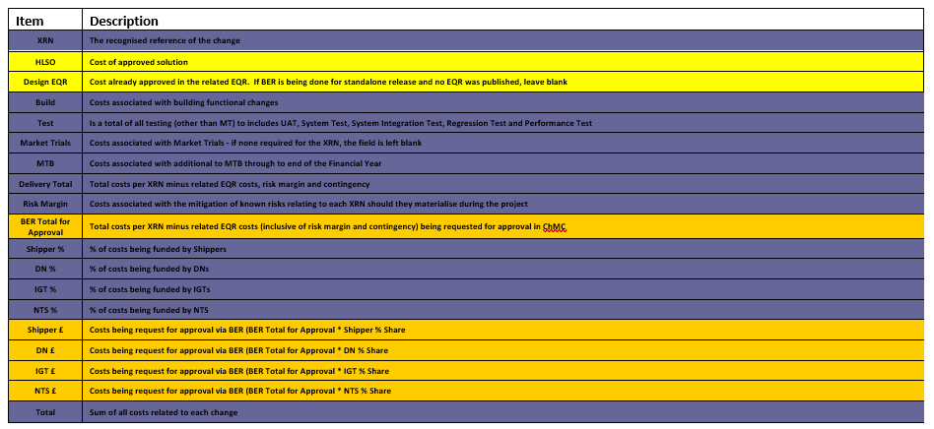
Section 4: Estimated impact of the service change on service charges
This change delivery will require additional operational effort. As stated in the BER for 5567: “The Refresh functionality … further requires Business Operation support which should be considered as a temporary activity until such time as the integration of the two systems are effective. This BER does not include the Operational team effort, but proposes that this is considered as part of XRN5535 – which will consider the remedial action needed for missing messages that have occurred and the necessary process changes in the event that instances occur in the future.”

This Change Proposal will include a new DSC Service Line that where the CDSP is made aware that the Registration details in UK Link are not aligned to the Central Switching Service that it shall initiate prospective Registration in UKL.

As this is intended to only be added for a period of 2 years and then be subject to review – this is not intended to be added to MTB and is only shown in the table below for visibility.

XRN | Xoserve Service Area & Line | Impact | (+/-) Projected Change in Annual Cost
XRN5535 | Service area 1: Manage Shipper Transfers | Business Operations process initiation and reporting | + £44,000
Total |  |  | £44,000

Section 5: Project plan for delivery of the change
We cannot provide a plan for this activity as we are entirely reliant on the Switching Operator providing the necessary reconciliation response regarding messages that have been missing to date.

Dependencies:
- Receipt from the Switching Operator of the ‘proxy Secured Active Notification’ for the manual reconciliation.
- Implementation of XRN5567 / REC CP R0067 for Refresh functionality

Section 6: Additional information relevant to the proposed service change
Issues:
This project will not solve the missing message problem. This change will require continued exception management by gas industry parties as CSS and UKL Registration Effective Dates will not align where refresh functionality will be used. These exception management processes will need to remain until further REC Change is progressed.

Please send completed form to: box.xoserve.portfoliooffice@xoserve.com

Document Version History
Version | Status | Date | Author(s) | Summary of Changes

Template Version History
Version | Status | Date | Author(s) | Summary of Changes
2.0 | Approved | 17/07/18 | Rebecca Perkins | Template approved at ChMC on 11th July
3.0 |  | 23/06/2021 | James Rigby | Table added to section 1  More detailed table in section 3  More detailed table in section 4  Inserted a project plan example in section 5  Table added in section 6

