DSC Business Evaluation Report (BER)

Change Title | Gemini Sustain Plus Programme
Xoserve reference number (XRN) | XRN5564
Correla Project Manager | Rachel Addison
Email address | Rachel.Addison@correla.com
Contact number | 0121 229 2528
Target Change Management Committee date | 9th November 2022
Section 1: In Scope
The Gemini Sustain Plus programme will deliver on the industry pain points whilst modernising the Gemini application and improving the user experience of the Gemini system.

Delivery of the Gemini Sustain Plus programme will include:
- Conversion of all the current Gemini functionality and code into modern (Java Microservices) code
- Delivery of additional functional requirements as per the baselined Functional Requirements
- Delivery in line with non-functional requirements as per the baselined Non Functional Requirements
- Consolidation and re-design of Gemini screens and system Integration layers
- Implementation of Azure cloud infrastructure components (including replacement of the current Oracle database)
- Improvements to the support service arrangement to respond better to incidents and change (in line with new service levels and KPIs)

There will be GT&M and Correla points of contact throughout the delivery and regular communication will be provisioned through the various industry forums.

Section 2: Out of Scope
- Any Production defect identified during project delivery unless it is pertinent to the success of this change.
- Any requirements not captured in the baselined Functional/Non Functional Requirements log.

Section 3: Funding required to deliver the change
The following section outlines the proposed costs

XRN Ref | HLSO £ | Design EQR | Build £ | Test £ | Implementation PIS £ | MT £ | 1st Year MTB £ | Delivery Total | CSSC Imact £ | Risk Margin £ | BER Total for Approval £ | Shipper £ | DN £ | IGT £ | NTS £ | Total
5564 | n/a |  |  |  |  |  |  | 13,000,000 |  | £0 | 13,000,000 | n/a | n/a | n/a | 13,000,000 | 13,000,000

XRN Ref | FY 22/23  £ | FY 22/23  £ | FY 22/23  £ | Delivery Total | Risk Margin £ | BER Total for Approval £ | Shipper £ | DN £ | IGT £ | NTS £ | Total
5564 | 3,670,000 | 6,400,000 | 2,930,000 | 13,000,000 | £0 | 13,000,000 | n/a | n/a | n/a | 13,000,000 | 13,000,000

Please note: This change is following the SAFe agile delivery approach.

Key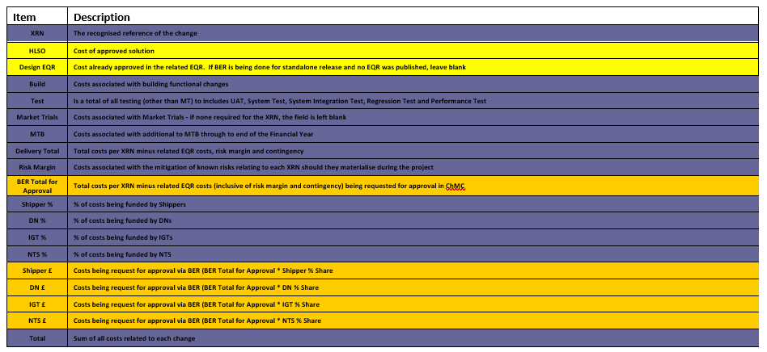
Section 4: Estimated impact of the service change on service charges
XRN | Xoserve Service Area & Line | Impact | (+/-) Projected Change in Annual Cost
5564 | Service area 14: Gemini Services | Reduced Annual Costs following migration to new platform | - £1,000,000
Total |  |  | £1,000,000

Section 5: Project plan for delivery of the change
The Gemini Sustain Plus Programme will follow the SafeAgile methodology and will be based on Program cycles of 10 weeks in duration. The programme commenced on 1st October 2022 with all activities to be completed by 30th September 2024.

Section 6: Additional information relevant to the proposed service change

Please send completed form to: box.xoserve.portfoliooffice@xoserve.com

Document Version History
Version | Status | Date | Author(s) | Summary of Changes

Template Version History
Version | Status | Date | Author(s) | Summary of Changes
2.0 | Approved | 17/07/18 | Rebecca Perkins | Template approved at ChMC on 11th July
3.0 |  | 23/06/2021 | James Rigby | Table added to section 1  More detailed table in section 3  More detailed table in section 4  Inserted a project plan example in section 5  Table added in section 6

