DSC Business Evaluation Report (BER)

Change Title | UK Link November 22 Major Release
Xoserve reference number (XRN) | 5516
Correla Project Manager | Surfaraz Tambe
Email address | surfaraz.tambe@correla.com
Contact number | 0121 229 2693
Target Change Management Committee date | 08th June 2022
Section 1: In Scope
This BER requests approval for funding of this UK Link Release, which consists of 2 XRNs, and is proposed to be implemented in November 2022. The delivery cost of £369,497 includes the EQR and a risk margin (specific per-change risks as listed below).

XRN | Title | Type | Description | Link to Change Proposal | Impacts
4978 | Notification of Rolling AQ Value (following Transfer of Ownership between M-5 and M) | Regulatory | Provide the new User with a view of the amended AQ/SOQ  (there is already an approved change to provide a report for this  scenario for Formula year values) | https://www.xoserve.com/change/change-proposals/xrn-4978-notification-of-rolling-aq-value-following-transfer-of-ownership-between-m-5-and-m/ | Shipper
4990 | MOD0664 –Transfer of Sites with Low Read Submission Performance from Class 2 and 3 into Class 4 | Regulatory | MOD0664 creates an obligation for shippers to transfer the  poorest performing supply points in class 2 and 3 (in terms of read  submission performance) into class 4. Read submission performance will be measured at supply point level, with those supply points falling below a specified benchmark for a consecutive period being transferred to class 4. If after a period of time, where a shipper does not move supply points that have not met the read obligation, the CDSP will automatically move those supply points to class 4. | https://www.xoserve.com/change/change-proposals/xrn-4990-transfer-of-sites-with-low-read-submission-performance-from-class-2-and-3-into-class-4-mod0664/ | Shipper

Section 2: Out of Scope
- Any additional changes
- Market Trials
Section 3: Funding required to deliver the change
The following section outlines the proposed costs for XRN5516, including the previously agreed EQR for Design. Costs highlighted in amber are for approval.

BER Costs

XRN  Ref | HLSO  £ | Design  EQR | Build | Test | Implement’n  PIS | MT | 1st Year  MTB | Delivery  Total | Risk  Margin | BER Total for  Approval | Shipper  % | DN  % | IGT  % | NTS  % | Shipper  £ | DN  £ | IGT  £ | NTS  £ | Total
4978 | £150,000 | £3,700 | £13,485 | £50,444 | £12,135 | £0 | £11,550 | £87,615 | £30,600 | £118,215 | 100% | 0% | 0% | 0% | £118,215 | £0 | £0 | £0 | £121,915
4990 | £150,000 | £7,250 | £81,641 | £83,525 | £30,467 | £0 | £36,550 | £232,182 | £19,100 | £251,282 | 100% | 0% | 0% | 0% | £251,282 | £0 | £0 | £0 | £258,532
Total | £300,000 | £10,950 | £95,126 | £133,969 | £42,602 | £0 | £48,100 | £319,797 | £49,700 | £369,497 | 100% | 0% | 0% | 0% | £369,497 | £0 | £0 | £0 | £380,447

Key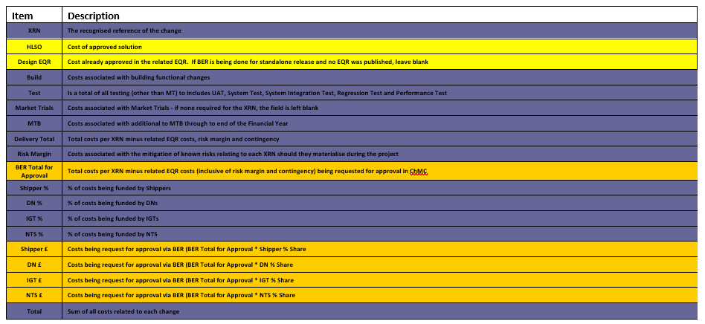
Section 4: Estimated impact of the service change on service charges
Impacts to Ongoing Costs

XRN | Xoserve Service Area | Impact | (+/-) Projected Change in Annual Cost
4978 |  | Technical Operations additional Monitoring | £11,550
4990 |  | Technical Operations additional Monitoring, including new DDP to ISU interface | £36,550
Total |  |  | £48,100

Section 5: Project plan for delivery of the change
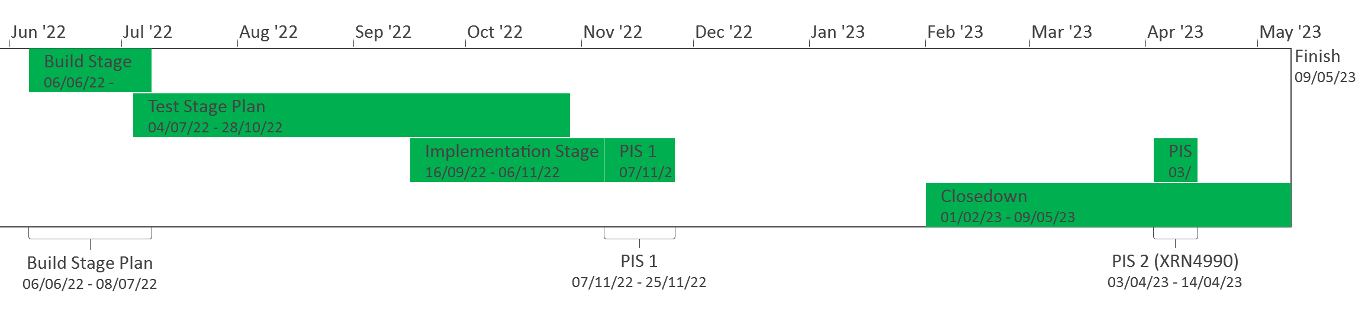
PIS will be split into 2 to cover the First Usage scenarios for XRN4990

ection 6: Additional information relevant to the proposed service change
Risk Margin

XRN Ref | Risk Margin | Description
XRN4978 | £7,200 | Change to requirements - timebound to end of PIS
XRN4978 | £1,800 | MTB Costs could increase or decrease as we go through the release and more understanding of the MTB work post implementation is available - timebound to end of PIS
XRN4978 | £1,600 | There is a risk that additional CPU and or storage required as a result of RT and PT testing which could lead to degradation of the BAU service - timebound from testing to PIS
XRN4978 | £20,000 | Environment sizing greater that the standard offering due to changes to NRL file - timebound to end of testing
XRN4990 | £12,800 | Change to requirements - timebound to end of PIS
XRN4990 | £3,300 | MTB Costs could increase or decrease as we go through the release and more understanding of the MTB work post implementation is available - timebound to end of PIS
XRN4990 | £3,000 | There is a risk that additional CPU and or storage required as a result of RT and PT testing which could lead to degradation of the BAU service - timebound from testing to PIS
Total | £49,700

Please send completed form to: box.xoserve.portfoliooffice@xoserve.com

Document Version History
Version | Status | Date | Author(s) | Summary of Changes
0.1 | Draft | 13/05/2022 | Jon Follows
0.2 | Stakeholder Review | 16/05/2022 | Jon Follows | Updated
0.3 | Wider Stakeholder Review | 18/05/2022 | Jon Follows | Updated following review comments
0.3a | Alternative version 0.3 for consideration | 19/05/2022 | Peter Hopkins | Updated following senior stakeholder review comments
0.4 | For Xoserve review | 20/05/2022 | Peter Hopkins | Clean copy for Xoserve review
05 | For Xoserve approval | 25/05/2022 | Peter Hopkins | Updated following Xoserve review
1.0 | Submitted to ChMC for approval | 25/05/2022 | Peter Hopkins | None

