Disclosure Request Report
Update to DPM Conditionality Document to reflect the release of data to a User who is recorded as a Registered Shipper on CSS (the CSS Recorded Shipper), but are not recorded as the Registered User on the UK Link system
Prepared by: | David Addison
Submitted for: | DRR-JAN-02-23
Decision details: | CoMC is requested to approve this request to amend the Data Permission Matrix Conditionality Document to allow Provision of data to a User who is recorded as the Shipper on the Central Switching Service, but are not recorded as the Registered User in the UK Link system
Date: | 9th January 2023

- Introduction and background
Following implementation of the Central Switching Service (CSS) there have been a number of instances where CSS Market Messages sent by the CSS to Switching Data Service Providers (SDSP) are either not being generated by the CSS, not being received or accepted by the SDSP or being received after Gate Closure. Where these messages relate to Registrations this has meant that Registrations have been set to Active within the CSS, but have not been reflected in the UK Link system and therefore the Shipper identified in the CSS Registration is not recorded as the Registered User in the UK Link system until such time that the exception can be resolved and the two systems brought into alignment as shown in the diagram below. This shows that for a period of time Shipper B is recorded as the Shipper within CSS (i.e. the CSS Recorded Shipper), but the Shipper is not recorded as the Registered User on UK Link systems – as denoted by the red horizontal dashed line.
During this period the UK Link system will still allow Shipper A recorded as the superseded Shipper in CSS to update the Supply Point Register, and will prevent Shipper B from doing so.
For this period we are proposing that we would provide specific supporting information to the ‘CSS Recorded Shipper’ – i.e. Shipper B in the illustration below– as if they were the Registered User recorded on the UK Link system. This DRR proposes amendments to the Data Permissions Matrix Conditionality Document to define the ‘CSS Recorded Shipper’ and to summarise the reports that will be available to these Shippers. The definition of the CSS Recorded Shipper is described in Section 3 of the document as “a Shipper who is recorded on the Central Switching Service as the registered Shipper, but as a result of the ‘missing message’ issue is not recorded as the Registered User (i.e. Portfolio Shipper) in the UK Link system.”

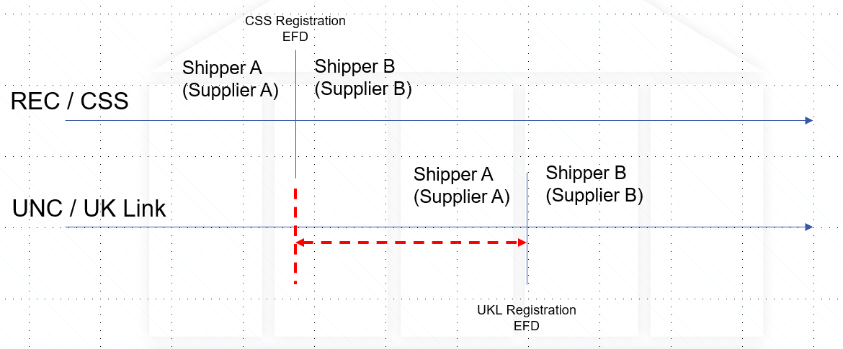

- Data items
We are proposing that the CSS Recorded Shipper will be able to request the following information:
- A report to provide the updates to the Supply Point Register for the period that the Registrations within CSS and UKLink systems are misaligned – i.e. for the period between the CSS Registration EFD and the UKL Registration EFD. The updates to the Supply Point Register would be related to the Supply Meter Point detail – i.e. Annual Quantity Corrections; Meter Reading detail and Meter Information. It is also proposed that we would identify if an update to consumer details had taken place within this period – but not the content of any such updates.
- A report to provide information related to updates to the Supply Meter Point detail that were rejected from the CSS Recorded Shipper for the period that the Registrations within CSS and UKLink systems are misaligned.

We propose that report a) needs to be recorded within the Data Permissions Matrix Conditionality Document to define that the information detailed will be released to the CSS Recorded Shipper.

We propose that the reporting structures are developed as part of XRN5535 ‘Processing of CSS Switch Requests Received in ‘Time Period 5’.

- Privacy Impact Assessment
Where the disclosure of information includes the processing of personal data a Privacy Impact Assessment may be required.
Xoserve has considered the various tests that may be applied and considers that none of these are met and so a Privacy Impact Assessment is not required.
The tests (and answers) applied in determining whether a Privacy Impact Assessment was required were:
a) Will the project involve the collection of new information about individuals?
No, this is existing data which is already available in Xoserve systems.
b) Will the project compel individuals to provide information about them?
No, the data is already used part of existing processes.
c) Will information about individuals be disclosed to organisations or people who have not previously had routine access to the information?
No, this data does not include information about an individual that the Shippers cannot already access.
d) Are you using information about individuals for a purpose it is not currently used for, or in a way it is not currently used?
No.
e) Does the project involve you using new technology that might be perceived as being privacy intrusive? For example, the use of biometrics or facial recognition.
No.
f) Will the project result in you making decisions or acting against individuals in ways that can have a significant impact on them?
No.
g) Is the information about individuals of a kind particularly likely to raise privacy concerns or expectations? For example, health records, criminal records or other information that people would consider to be private.
No.
h) Will the project require you to contact individuals in ways that they may find intrusive?
No, there is no requirement to contact individuals.
i) Will the disclosure of information utilise new technology for Xoserve?
No.
j) Will the disclosure include information that identifies a vulnerable customer?
No.
k) Will the disclosure release mass data to a party?
No.
l) Will the disclosure include information that identifies an occurrence of theft of gas?
No.
m) Will the disclosure require a fundamental change to Xoserve Business?
No.

- Commercial model
It is proposed that the reporting will be provided to Shippers as part of the resolution of missing messages if requested. It is not intended to be undertaken as an Additional Service.

- Method of access to the dataset
Access to the dataset will be provided by sending reports to Shippers.
- CoMC determinations
CoMC is requested to approve this Disclosure Request Report.

