0674 – LEGAL TEXT MAPPING

Solution
The current Performance Assurance regime is represented diagrammatically below:
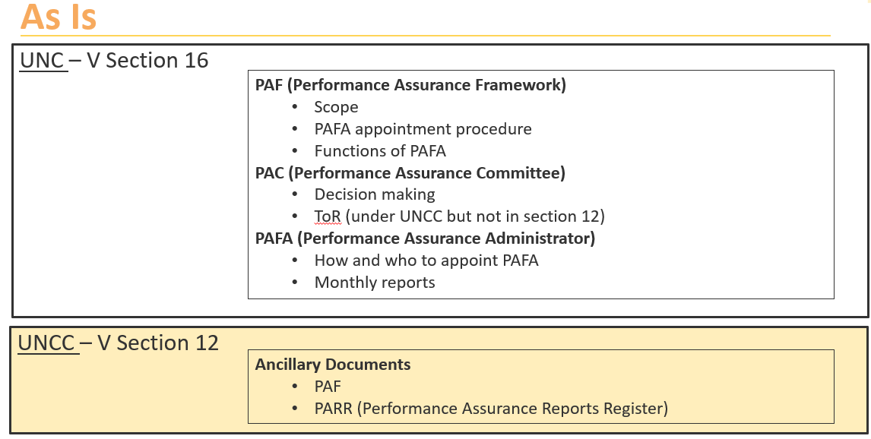
The modification will move Performance Assurance to a new regime represented diagrammatically here:
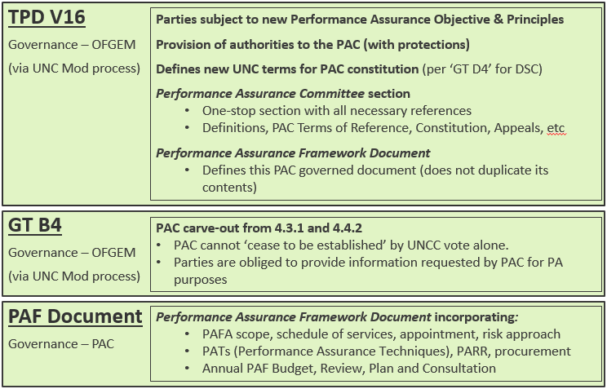
Key
Text legal text included in drafting
Text no legal text included in drafting, but may not be needed
In summary the solution is to oblige UNC Parties (transporters, shippers) and CDSP (via DSC 3.5) to comply with an objective of equitable settlement and to cooperate with other Parties to further this objective.
It will also give PAC some additional authority to identify those areas of performance (whether in Code or not) which impact the objective, to require UNC Parties to improve in those areas and to impose sanctions where performance is below the required level. It will also require Proposer of a modification which adds or changes UNC performance standards or might impact a Party’s performance against such standards to specify an appropriate monitoring report. The CDSP will be required to provide a ROM (rough order of magnitude) for workgroup consideration
The requirements below will be incorporated into the UNC.
(Associated changes will be made to the Performance Assurance Framework documents).
- Introduce a new objective to the UNC, the Performance Assurance Objective (PAO)
The Performance Assurance Objective is :
  - To ensure that Settlement is a timely, accurate and equitable share of energy for each shipper. See V16.1.1.
- Introduce a new overarching principle to the UNC
The Modification Panel, UNCC, sub-committees and Parties must always ensure that acts (or omissions) contribute to, and do not prejudice, the achievement of the Performance Assurance Objective even when such acts or omissions are not explicitly proscribed under UNC. See V16.1.2(a), (b), (c) and (d).
  - The acts or omissions of any other Party (such as another shipper, supplier or their agent) do not absolve any other Party of their obligations under the UNC. See V16.1.2(e).
  - Parties acknowledge that reports provided by PAFA or PAC shall constitute evidence of a Party’s performance with regard to UNC compliance, and shall be accepted as such unless evidenced to the contrary.
  - Parties will use these reports to self-monitor performance.
  - Parties will also respond to PAFA/PAC enquiries with the requested information, timeously and in accordance with such process as may be specified in PAF Document from time to time. See V16.1.5 and GT B4.2.2.
- Introduce a new overarching principle to the UNC of collective co-operation towards the specified objective.
  - All UNC Parties acknowledge that each is dependent on the others for the achievement of the PAO and will cooperate wherever is necessary (whether explicitly required in UNC or not) to achieve the PAO . See V16.1.3.
- Move responsibility for the PAF Document preparation and maintenance from DNO to PAC (and submitted to UNCC for information). See V16.4.1(a).
- Define the PAC in V16, as an autonomous UNC sub-Committee following the principle used in General Terms D4 for DSC sub-Committees. PAC and PAFD will no longer be governed under Section V12 of UNC. See V16.2.1 and 16.2.4 and deletions at V12.1.
On advice from Joint Office I have included below proposed drafting as it would apply to PAC, and shown under each main heading of General Terms Section D 4.1 – 4.5. This drafting contains the rules proposed by the modification and intended as a ‘construction guide’ for Legal Text Provider, it does fetter their discretion to draft legal text as it see fit.
PAC COMMITTEE
4.1 Establishment and functions of the Performance Assurance Committee
4.1.1 In connection with the requirement to operate the UNC Performance Assurance Regime the following Network Code Sub-committee is established:
(a) The Performance Assurance Committee (PAC) See V16.2.1.
4.1.2 The Performance Assurance Committee shall perform the functions and have the powers and duties provided in this section UNC V16, and the Performance Assurance Framework Document See V16.2.2.
4.1.3 The Performance Assurance Committee shall have control of the following documents:
- Document 1: Performance Assurance Reports Register (PARR) See V16.4.1(g).
- Document 2: The Risk Register See V16.4.1(g).
- Document 3: PAC letters of confirmation and company agreement See V16.4.1(h).
- Document 4: PAFA scope See V16.4.1(f) and 16.9.4(a).
- Document 5: PAF Document See V16.4.1(a).
4.1.4 A PAC Committee may establish a sub-committee for such purposes (within the scope of its functions, powers and duties) and comprising such members and on such terms as it decides; and references to a PAC Committee include any such sub-committee. See V16.2.3.
4.1.5 The PAC Committee is autonomous, and the UNC Committee has no power to overrule a decision of the PAC or its sub-committees or reduce or qualify the scope of its functions, powers, and duties. See V16.2.4.
4.1.6 No decision of the PAC shall be made or (if made) shall be effective if the decision would cause a party to be or act in breach of the UNC. See V16.2.5.
4.2 Constitution of the PAC
4.2.1 The PAC shall comprise representatives (“Committee Representatives”) of each Customer Class as follows:
(a) 9 individuals appointed as representatives of Shipper Users (“Shipper User Representatives”); and See V16.3.1(a).
(b) 3 individuals appointed as representatives of Transporters and IGTs, of which:
(i) 2 shall be appointed by DN Operators (“DNO Representatives”); and
(ii) 1 shall be appointed by IGTs (“IGT Representatives”). See V16.3.1(b).
For the avoidance of doubt NTS shall not have membership rights
4.2.2 For PAC to fulfil its role under the PAF, its Shipper members shall be appointed using the guidelines as defined in the UNC governed document:
‘Uniform Network Code Panel, Uniform Network code committee (UNCC), Sub-Committees and Data Services Contract (DSC) Committees - Guidelines for the User Representative Appointment Process’
https://gasgov-mst-files.s3.eu-west-1.amazonaws.com/s3fs-public/ggf/page/2019-06/UNC%20User%20Representative%20Appointment%20Process%20v3.0.pdf
See V16.3.2(a).
4.2.3 For PAC to fulfil its role under the PAF, its membership must behave in a manner that is consistent with the principles of the PAF and the duties of the PAC.
PAC Members are representatives in their own right and do not represent the company by which they are employed.
All PAC Members and their alternates will be required to sign the following documents to assure that the Member will be attending and voting at the PAC in the interests of the GB gas industry and not representing any commercial interest or commercial body or interest group:
- Letter of Confirmation, which includes
    - Member impartiality
    - Non –Disclosure Agreement
    - Declaration of interest.
- Letter of agreement from Company Employing a committee member
- And if applicable, Letter of Agreement from company nominating a committee member
The documents listed above are controlled by the PAC and can be found in the PAC Framework Document. See V16.4.1(h).
4.2.4 Committee members and alternates
A list of all PAC Members and standing alternates is published on the Joint Office website.
Alternates need not necessarily come from the same company as the PAC Member. It will be for the PAC Member to consider the suitability of their alternate, in respect of experience and understanding of the issues that the PAC will deal with. For the avoidance of doubt a PAC Member can act as Alternate for another PAC Member See V16.6.1 (relying on MR4.5).
A single alternate may not represent more than one (1) other PAC Member, unless a quorum cannot be achieved without this happening.
4.3 Voting arrangements
4.3.1 Each Committee Representative shall hold one (1) vote;. See V16.5.1.
4.3.2 A decision of the PAC Committee shall be made in accordance with UNC TPD V16.2.1:
See V16.5.2 and 16.5.3.
4.4 Proceedings of PAC Committee meetings
4.4.1 The meeting will be quorate where there are at least four Shipper User PAC Members and two Transporters (DNO and/or IGT) PAC Members present with a minimum of six PAC Members in attendance. See V16.6.2.
4.4.2 The Code Administration Code of Practice shall apply to the conduct of the meetings.
4.4.3 Information to be used within meetings will be provided to PAC Members, the Joint Office and the Ofgem representative via a secure web portal. Such information shall not be downloaded.
4.4.4 PAC members, the Joint Office and Ofgem shall treat all information as confidential unless it is clearly marked otherwise.
4.4.5 The default is PAC meetings are ‘closed’ to non-Members. PAC Members can agree to hold ‘open’ meetings. See V16.6.4 and 16.6.5.
4.4.6 With agreement of the Chairperson, and for example for the purposes of but not limited to developing the PAC arrangements or carrying out investigations into performance, PAC Members can invite 3rd parties and non-members to the meeting See V16.6.5.
4.4.4 The CDSP may be required to attend (by one or more representatives) meetings of the PAC. See V16.6.3.
4.5 Appeal
4.5.1 To enable it to deliver upon its purpose of identifying and mitigating gas Settlement inaccuracy, the gas PAFD gives PAC the power to apply Performance Assurance Techniques (PATs) to various industry roles. See V16.4.1(e)
4.5.2 The parties to whom the PATs are applied (the subject of a PAT) can be materially affected, financially, operationally or reputationally, by their application.
4.5.3 The party subject to a PAT may believe that the accuracy of the information underpinning PAC’s use of a PAT is materially and demonstrably incorrect. It may also believe that the procedure surrounding use of the PAT, as set out in the PAT technical document, has demonstrably not been followed, resulting in a material impact on them. See V16.8.2
4.5.4 In these circumstances, the subject of the PAT is entitled to appeal the PAC’s decision to the PAC. The decision of the PAC, having considered any new information arising from any UNCC appeal, is final. See V16.8.9.
4.5.6 The criteria for a valid appeal, is as follows:
- The inaccuracy of fact or irregularity of procedure can be demonstrated, such that there is specific alternative information on which PAC should instead rely or a specific alternative way in which a procedure should have been enacted See V16.8.2(a).
- A material inaccuracy of fact or irregularity of procedure has occurred, such that the outcome would be different if the correct information or procedure were used instead See V16.8.2(b).
- The appeal must be raised with the PAC within [1 month] of the relevant PAC decision See V16.8.3.
- Where the appellant is appealing a PAC decision to refer the appellant to Ofgem, the appellant will have a second appeal opportunity that will be heard by the UNCC in such circumstances.
4.5.7 Procedure
- The gas PAFA will assess any appeal in respect of whether the criteria for the appeal has been met and regarding the PAC’s use of a PAT in the light of the new information provided, before presenting the appeal to PAC at the next practicable opportunity. See V16.8.4.
- The PAFA’s initial views on the validity of the appeal and the appropriate rectification will be presented to the PAC alongside the appellant’s representations. See V16.7.4(d).
- PAC’s original reasons for applying the PAT will form part of the material PAFA reviews and provides to PAC to aid its decision on the appeal. See V16.8.4.
- During the period between an appeal being raised and the PAC hearing the appeal, any obligations on the appellant, PAC and PAFA pursuant to a PAT which is wholly or partly the subject of the appeal will be suspended. See V16.8.4(b).The PAC’s decision on the appeal will include guidance for resumption or termination of timescales for action under any of the PATs at issue.
- The PAC will treat the matter as confidential. All meetings to hear the appeal will be closed and the meeting and the material presented for consideration during an appeal will not be published. See V16.8.4(e).
- The appellant may be invited to present their case and their supporting evidence. Notice of the meeting will be not less than [two weeks]. See V16.7.4(d).
- The PAC will determine the extent to which it accepts the appeal. This could be wholly, partially or not accepted. The PAC may recommend or provide guidance on how or whether the application of the original PAC decision resumes or continues. See V16.8.4(f).

4.5.7 Appeal Decision
- The PAC will respond in writing to the appellant within [two weeks] of making their decision with the reasons for its decision. See V16.8.4(g).
- Where the appellant remains of the view that their reason for appeal is valid and that the PAC have not taken fair and balanced view of their evidence, the appellant may appeal to Ofgem. Any PAT’s may resume or be continued until Ofgem provides its decision. The decision of Ofgem will be final. See V16.8.6, 16.8.7 and 16.8.8.
- Section V16 will include amongst other things the following:
    - The UNC Performance Assurance Objective and other terms pertaining to PAC See V16.1.1.
    - the composition of the Performance Assurance Committee membership (as per the present TOR 2.2); See V16.3.1.
    - the basis on which Performance Assurance Committee members are to be appointed and from time to time removed and/or replaced This to include that each User and its Affiliates holding more than one Gas Transporters Licence may submit up to one nominations for the purposes of the appointment process. See V16.3.2. This rule exists in the current User Representative Appointment Process Document guidelines (page9).
    - the basis on which a person (not being a committee member) will be appointed to chair each meeting of the Performance Assurance Committee; See V16.3.3.
    - the basis on which a person (not being a committee member) will be appointed as secretary to the Performance Assurance Committee; See V16.3.4.
    - the voting arrangements and the basis on which decisions of the Performance Assurance Committee will be made; Each Committee Representative shall hold one (1) vote;
Where the meeting is quorate, all decisions shall be made by simple majority of exercisable votes of PAC Members or their nominated alternate in each of both Shipper and Transporter constituencies. PAC Members may vote for or against a proposal, any abstention shall not count towards the simple majority count. Where such a majority is obtained in one but not both Shipper and Transporter constituencies, the resolution shall be treated as not passed
See V16.5.1, 16.5.2 and 16.5.3.
    - the basis on which decisions of the Performance Assurance Committee may be appealed to the Authority (see section 4.5 italics above). See V16.8.6.
    - Definition of the Performance Assurance Framework Document and its purpose and governance (removing it from V12 and moving it to a PAC-governed document) See V12.1, V16.4.1(a), 16.7.1 and 16.7.2.
    - UNCC will have no power to overrule a decision of the PAC or its sub-committees, or to reduce or to qualify the scope of PAC’s functions, powers and duties (per GTD4 treatment for DSC) See V16.2.4.
    - No decision of PAC shall be made if the decision would cause a party to breach UNC See V16.2.5.
    - Specify PAC controlled documents as being Performance Assurance Reports Register (PARR), The Risk Register, PAC letters of confirmation and company agreement, PAFA scope, PAFD See V16.4.1.
    - Definition of the Performance Assurance Party being a party who will be subject to Performance Assurance Objective (either a Party to UNC, CDSP or any other party whose performance or non-performance of activities governed directly or indirectly under UNC) and whose acts or omissions could impact another PAP’s contribution to the Performance Assurance Objective See V16.1.1.
- Give PAC authority in the UNC, with relevant protections noted below, to include:
- To determine the performance and applicable assurance monitoring and incentive tools to be applied to a Party, consistent with those defined in the PAFD, as amended by PAC from time to time See V16.4.1.
- PAC will be added to “UNC – Modification Rules 6.1.1” as a Proposer to raise performance-related modifications. This has the benefit that the proposal is bi-partisan, and in the interests of the industry not a single UNC Party. Controls over this power will be that the proposal is See MR6.1.1(e).
    - subject to agreement by a simple majority of all PAC members, (this might require ex-Committee voting if not all members have attended the meeting), and See V16.5.1, 16.5.2 and 16.5.3.
  - restricted to changes reasonably considered to impact on the achievement of the Performance Assurance Objective (for example where rules on process or performance are proven to be unnecessary / ineffective). See MR6.1.1(e).
  - Subject to the same process as for any other modification through UNC Mod Panel
[Just for context, such mods could be drafted by (but not limited to) CDSP (include this as a Direct Function) or PAFA (include as a Document 4 service). (This will make industry change more agile … for example UNC721 & 722 could have been raised by PAC and drafted by XoServe or PAFA immediately following the 24th March PAC meeting when the prospect of overstated allocation was first raised)]
- PAC will define those areas of a Party’s or of Parties’ performance which impact the PA Objective. PAC will set the tolerance threshold and determine those levels at which Performance Assurance Techniques will apply. PAC will require UNC Parties to improve in those areas and will have powers to impose sanctions where performance is below the required level, provided the thresholds, areas and sanctions/techniques are consistent with what is defined from time to time in the PAFD See V16.7.4 and in PAFD.
- Require parties to respond to and meet PAC requests reasonably made in the context of performance matters and in pursuit of the Performance Assurance Objective. This requires a carve-out under GT Section B4.4.2 See GTB4.2.2.
- Deploy Performance Assurance Techniques (PATs) described in the PAFD as they deem appropriate, including applying derogations where reasonable and appropriate (for example where performance is impacted by pandemic, events of force majeure or industry developments). In PAFD.
- Parties acknowledge that such techniques could include publishing on the Joint Office website the company names and performance (only) of Parties to allow peer comparison. Such information will be limited to the performance measures outlined in PAFD from time to time. In so doing, PAC will not divulge any information on the Parties’ specific commercial or operational arrangements, the reasons for the level of performance or any details of the improvement plans. In PAFD.
- The Proposer of a modification will be required to seek a ROM from XoServe for workgroup consideration of the impact of their modification proposal where such proposal
  - adds or changes UNC performance standards or
  - impacts a Party’s performance against such standards to specify an appropriate monitoring report.
- Definition of the Performance Assurance Framework Document and its purpose and governance (including PAC authority to change and the voting arrangements for such amendments to PAFD) See V16.7.1 and 16.7.2.
- Remove the UNC requirements for UNC approval of changes to PARR (remove PARR from UNC Related Documents and UNC governance, delete V12.1(h) and 16.5.2). PARR becomes an Annex to PAFD subject to PAC Governance. The principle here is to remove unnecessary barriers to data access which reduce the effectiveness of performance assurance See deletions at V12.1 and V16.7.1 and 16.7.2.
- Request reports or data that it deems required to understand performance issues, causes and materiality of impact on the Performance Assurance Objective. See V16.1.5.
PAC will advise UNCC of any changes to data access rights.
- Remove references to PARR Schedule 1 which is now obsolete.
- Clarify that both PAC and PAFA may see all data requested un-anonymised, so including shipper names; this is not limited to PARR ‘B’ schedules as Xoserve interprets 16.5.3. PAC members have signed confidentiality provisions and acknowledged that they’re acting on behalf of GB Gas industry. PAFA are bound by confidentiality terms in their agreement with CDSP. There should be no reason to bar PAC from access to information that it reasonably requires for performance assurance
- Such un-anonymised data or information to include anything that PAC reasonably requests in pursuit of their duties under UNC and at least but not limited to i) all data identified in DPM ii) all data available in DDP iii) all such other data items or information held by CDSP iv) anything else that CDSP can reasonably obtain subject to DSC approval.See V16.4.

- PAC may establish a sub-committee for such purposes (within the scope of its functions, powers and duties) and comprising such members and on such terms as it decides See V16.2.3.
- PAC may submit DSC Change Proposals which may include internal and/or external costs. Such requests are:
  - limited to investigations and analysis of settlement, performance of PAPs and related matters reasonably considered to impact on the achievement of the Performance Assurance Objective (for example where rules on process or performance are proven to be unnecessary / ineffective), and
  - subject to agreement by a simple majority of all PAC members, (this might require ex-Committee voting if not all members have attended the meeting), and
  - Subject to the same process as for any other proposals through DSC Change Management
- Requesting the remedy of performance issues, even where there is no explicit prescriptive performance standard specified in the code, where that performance issue is limiting or preventing the achievement of the Performance Assurance Objective (PAO) In PAFD.
- PAC Protections
- All shippers shall be required to nominate (and appropriate delegate) a person in their organisation to act in capacity as First Point of Contact in relation to all PAC correspondence (the “PAP Authoriser”), such person to have appropriate knowledge and authority so as to understand and instruct action to be taken in regard to such communication , including attending PAC if required and providing suitably informed escalation contacts up to director level should PAC require it. See V16.11.1 and 16.11.2.
- PAC, PAFA, JO and CDSP personnel and any other party attending closed PAC meetings may not reveal the workings or the decision making process in reaching any decisions, save when required by law or due to an appeal from any affected party. See V16.6.10.
- PAC, PAFA, JO and CDSP personnel and any other party attending closed PAC meeting are required to sign and adhere to undying non disclosure agreements and any confidential material downloaded must be deleted when no longer required and when ceasing to attend the PAC (for whatever reason), whichever is sooner. See V16.6.5 and 16.6.7.
- Using an approach similar to Section X for EBCC (which avoids the need for each and every Party to provide separate indemnities), Members (being persons) of PAC, PAFA and CDSP connected with a performance assurance decision should be protected from any litigation connected with the operation of the performance assurance regime See V16.13.
- PAC will be an elected and impartial committee with appropriate expertise to make assessments and judgements using the tools and evidence provided to inform actions in pursuit of the Performance Assurance Objective.
Individuals with an interest in any matter being discussed will declare it; PAFA will advise PAC if it becomes aware of potential conflict of interest. PAC members will apply their expertise without discrimination. See V16.6.8 and 16.7.9.
- Where PAC requests an interview with a party, the party is required to attend and send an individual(s) with the required expertise and authority. See V16.11.3.
- PAC is a UNC sub-committee, established under TPD V16 and cannot be amended without Authority approval; and it cannot under GTB4.3.1. ‘cease to be established’ by UNCC. See GTB4.3.1.

