DSC Business Evaluation Report (BER)

Change Title
Xoserve reference number (XRN)
Correla Project Manager
Email address
Contact number
Target Change Management Committee date
Section 1: In Scope
Please provide a detailed description of what is in scope of this delivery. In project management, scope is the set of boundaries that define the extent of a project. The scope describes what is to be delivered to the customer as a result of the project initiative. These deliverables are derived from a project's requirements.

XRN | Title | Type | Description | Link to Change Proposal | Impacts

Section 2: Out of Scope
Please provide details of any deliverables which are out of scope. If an activity falls outside the boundaries, it is considered “out of scope” and is not planned for. For Example
- Any additional changes
- Market Trials

Section 3: Funding required to deliver the change
The following section outlines the proposed costs

XRN Ref | HLSO £ | Design EQR | Build £ | Test £ | Implementation PIS £ | MT £ | 1st Year MTB £ | Delivery Total | CSSC Imact £ | Risk Margin £ | BER Total for Approval £ | Shipper £ | DN £ | IGT £ | NTS £ | Total

Key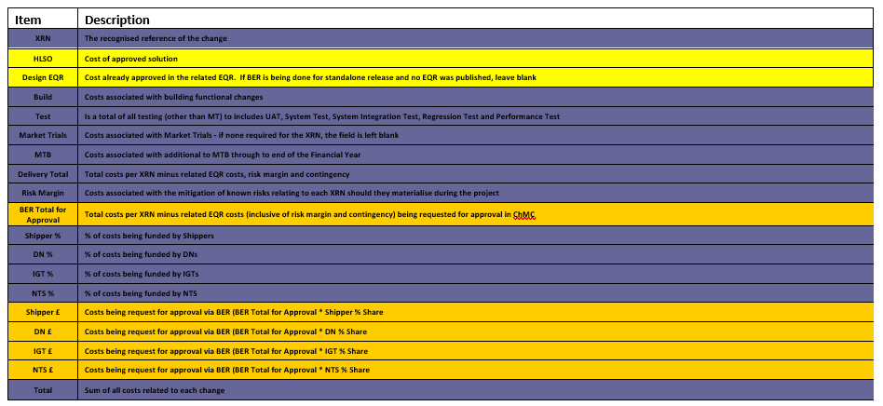
Section 4: Estimated impact of the service change on service charges
Please detail any projected increase or decrease in cost to any of Xoserve’s service areas, and within them any service lines, as a result of this change.
Impacts to Ongoing Costs Example

XRN | Xoserve Service Area & Line | Impact | (+/-) Projected Change in Annual Cost
XXXX | Service area 1: Manage Shipper Transfers  DS-CS SA1 – 56 | Technical Operations additional Monitoring | + / - £XXXX
Total |  |  | £XXXX

Section 5: Project plan for delivery of the change
Please insert a high-level plan for the delivery of the change
Example
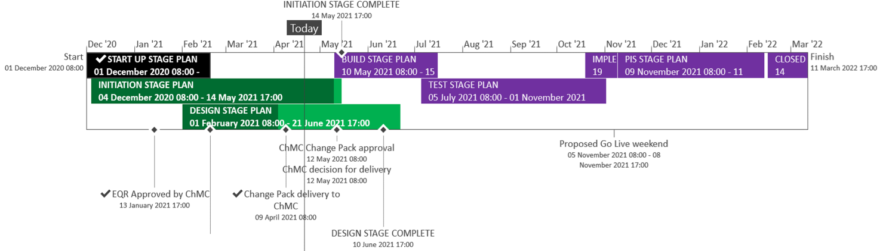
Complete
On Track
Planning (will not be baselined until delivery scope confirmed)

Section 6: Additional information relevant to the proposed service change
Risk Margin

XRN Ref | Risk Margin | Description
XXXX | £XXXX | Change to requirements - timebound to end of PIS
Please advise of any:
Constraints (any restriction that defines the project’s limitations)

Risks (any events that, should they occur, will have an effect on achieving the project’s objectives)

Issues (any problems which have already occurred and either have a positive or negative effect on the project’s ability to meet its objectives)

Assumptions (any statements that are taken as being true for the purposes of planning, but are subject to change)

Please indicate if any of the above will have external involvement. Who will be involved? When will they be involved, and how?

Please send completed form to: box.xoserve.portfoliooffice@xoserve.com

Document Version History
Version | Status | Date | Author(s) | Summary of Changes

Template Version History
Version | Status | Date | Author(s) | Summary of Changes
2.0 | Approved | 17/07/18 | Rebecca Perkins | Template approved at ChMC on 11th July
3.0 |  | 23/06/2021 | James Rigby | Table added to section 1  More detailed table in section 3  More detailed table in section 4  Inserted a project plan example in section 5  Table added in section 6

