DSC Business Evaluation Report (BER)

Change Title | UKLink June 20 Release
Xoserve reference number (XRN) | 4996
Xoserve Project Manager | Surfaraz Tambe
Email address | Surfaraz.Tambe@xoserve.com
Contact number | 01212292693
Target Change Management Committee date | 22nd November 2019
Section 1: In Scope
This BER requests approval for the full delivery of the June 20 UKLink Release, which consists of 7 XRNs, and is proposed to be implemented on 20th June 2020. There are ten changes in scope:

- XRN4772 - Composite Weather Variable (CWV) Improvements
Changes to add the new parameters in the files and calculating Forecast / Actual weather values. New process will be configured to load the new file containing weightage of parameters.
- XRN4850 - Notification of Customer Contact Details to Transporters
This change is raised to extract the information of end consumers and broadcast to them for any outages by GTs or iGTs. This will be achieved by storing the enhanced BP information received via CNC or CNF. The end consumers will be liable to STOP this if not required. CDSP also wants to record the usage of the service.
- XRN4865 - Amendment to Treatment and Reporting of CYCL Reads
Changes are required to the Read Tolerance checks on all the submitted reads. In addition, MBR file needs to be amended to send an E (estimate) for Confirmation Effective Date. Description in the [M03 BILLREADS] record (MBR file) formats require update.

- XRN4888 - Removing Duplicate Address Update Validation for IGT Supply Meter Points via CMS
Validation needs to be removed in CMS to stop processing the duplicate addresses. After this change; IGTs will be able to update duplicate addresses via CMS in UK Link. An additional report needs to be submitted highlighting how many such instances have occurred on daily and monthly basis.
- XRN4930 - Requirement to Inform Shipper of Meter Link Code Change
For change in the Meter Link Code; MRI (K15) will be triggered whenever there is a link code change in the system i.e. Prime to Freestanding or vice versa. This is done by the users manually at the back of exceptions.
- XRN4932 - Improvements to the quality of the Conversion Factor values held on the Supply Point Register (MOD0681S)
The conversion factor will be updated as part of AQ Updates above or below 732,000 kWh. Data Cleansing is required as part of the implementation.
- XRN4941 - Auto updates to meter read frequency (MOD0692)
The conversion factor will be updated as part of AQ Updates above or below 293,000 kWh. Data Cleansing is required as part of the implementation.
Section 2: Out of Scope
- Any other changes other changes than the changes specified above are out of scope.

Section 3: Funding required to deliver the change
XRN4772 - Composite Weather Variable (CWV) Improvements
Gas Industry Participant | % Share of Cost
Shippers | 50%
iGT’s
DNO’s | 50%
Transmission
DN & iGT

XRN4850 - Notification of Customer Contact Details to Transporters
Gas Industry Participant | % Share of Cost
Shippers
iGT’s | 10%
DNO’s | 90%
Transmission
DN & iGT

XRN4888 - Removing Duplicate Address Update Validation for IGT Supply Meter Points via CMS
Gas Industry Participant | % Share of Cost
Shippers
iGT’s | 100%
DNO’s
Transmission
DN & iGT

XRN4930 - Requirement to Inform Shipper of Meter Link Code Change
Gas Industry Participant | % Share of Cost
Shippers | 100%
iGT’s
DNO’s
Transmission
DN & iGT

XRN4932 - Improvements to the quality of the Conversion Factor values held on the Supply Point Register (MOD0681S)
Gas Industry Participant | % Share of Cost
Shippers | 100%
iGT’s
DNO’s
Transmission
DN & iGT

XRN4941 - Auto updates to meter read frequency (MOD0692)
Gas Industry Participant | % Share of Cost
Shippers | 100%
iGT’s
DNO’s
Transmission
DN & iGT

XRN4865 - Amendment to Treatment and Reporting of CYCL Reads
Gas Industry Participant | % Share of Cost
Shippers | 100%
iGT’s
DNO’s
Transmission
DN & iGT

Please see below for full cost breakdown (incl. Market Trials).

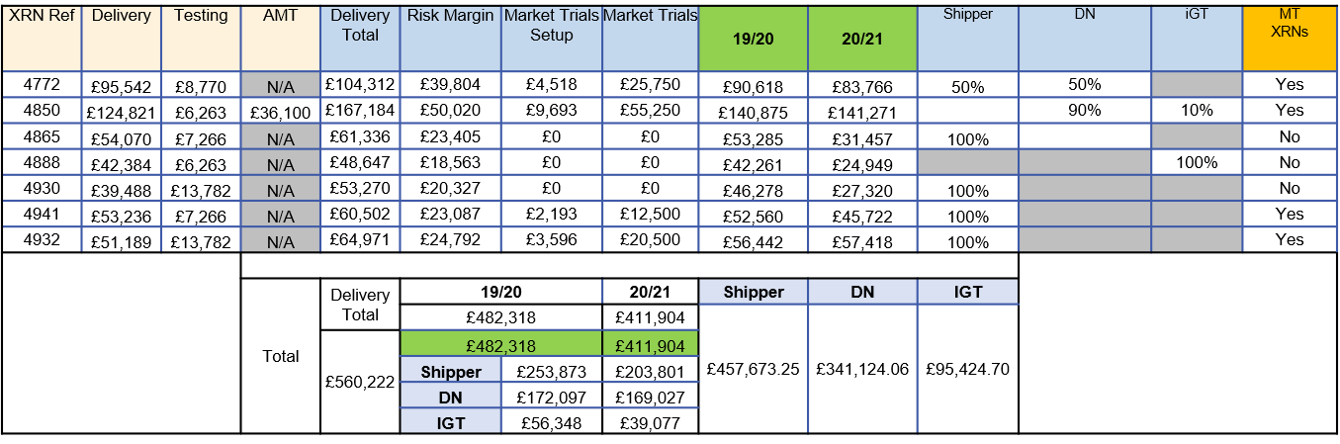

Total Costs of June 20 changes (incl. MT): £894,222
- Delivery cost: £560,224
- Market Trials: £114,000
- MT Set Up: £20,000
- Risk Margin: £200,000

Section 4: Estimated impact of the service change on service charges
TBC
Xoserve Service Area | Xoserve Service Line | (+/-) Projected Change in Annual Cost
TBC | TBC | TBC
Customer Benefits:

The changes will deliver change proposals requested by Market participants and items of scope from the UK Link Programme which were not identified or not delivered as part of the main UK Link implementation or previous future releases. It will also deliver changes mandated via modifications.

Full details of the benefits for each specific change are included in the HLSO’s which are attached in the appendix.

Service Description Table
Section 5: Project plan for delivery of the change
Section 6: Additional information relevant to the proposed service change
Risks:

- There is a risk of increased project spend should unforeseen issues occur which result in additional work, rework or delays to the project schedule
- There is a risk that there will be resource constraints throughout the project lifecycle because of multiple UKLink deliveries running in parallel
- There is a risk that additional customer and/or Xoserve change could be added to scope on completion and approval of a formal Change Request process.
- There is a specific risk for XRN4941 that several assumptions will be required in order to complete design and issue the change packs because MOD0692 has not been approved by Ofgem

Please send completed form to: box.xoserve.portfoliooffice@xoserve.com

Document Version History
Version | Status | Date | Author(s) | Summary of Changes
0.1 | Draft for review | 16/10/19 | Simon Burton | Initial draft
0.2 | For Approval | 08/11/19 | Simon Burton | For approval at ChMC on 13/11/19
0.3 | For Approval | 21/11/19 | Simon Burton | Revised due to descope, for approval at eChMC on 22/11/19

Template Version History
Version | Status | Date | Author(s) | Summary of Changes
1.0 | Approved | 15/06/18 | Rebecca Perkins | Document approved at CHMC External Workgroup
2.0 | Approved | 19/12/18 | Heather Spensley | Moved onto Xoserve’s new Word template in line with new branding

