UNC Request |  | At what stage is this document in the process?
UNC 0661R:  Reconciliation and Imbalance Cash Out Prices |  | 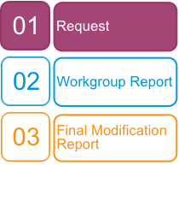
Purpose of Request:
This Requests aims to seek a method of incentivising Shippers to purchase the correct amount of gas for NDM sites, in advance of the gas day and support de-risking Shipper imbalance costs.
 | The Proposer recommends that this request should be assessed by a Workgroup  This request will be presented by the Proposer to the Panel on 18 July 2018.
 | High Impact:  Shippers
 | Medium Impact:  CDSP
 | Low Impact:

Contents  1 Request 3  2 Impacts and Costs 4  3 Terms of Reference 8  4 Recommendation 8  5 Appendix A – Current Issue 8  6 Appendix B – Potential Solutions 14  7 Appendix C - Imbalance Reconciliation Materiality Data 35  About this document:  This document is a Request, which will be presented by the Proposer to the panel on 18 July 2018.  The Panel will consider the Proposer’s recommendation and agree whether this Request should be referred to a Workgroup for review. |  Any questions?
Contact:
Joint Office of Gas Transporters
 |  enquiries@gasgovernance.co.uk
 | 0121 288 2107
 | Winchester Gas Distribution
Proposers Representative:
George MacGregor
 | georgemacgregor@utilita.co.uk
 | 07392866735
Systems Provider:
Xoserve
 | commercial.enquiries@xoserve.com

- Request

Why is the Request being made?
The CDSP estimate Shippers’ daily offtakes using the NDM Deemed Allocation. Shippers provide their daily NDM nomination information to the CDSP via UKLink. CDSP calculate the difference between this nomination and the NDM Deemed Allocation and the Shipper is then subject to an Imbalance Payment.
Imbalance payments pay out the difference between the Shipper’s Position and the NDM Deemed Allocation at SMSP/SMBP.
Shippers can then submit actual NDM meter reads into UKLink. The difference between the actual meter reads and the NDM Deemed allocation is then calculated and a reconciliation payment is made to the Shipper. These payments are made at SAP.
The fact that different system prices are used for these calculations creates a financial disincentive for Shipper’s to submit accurate forecasts. Purchasing over or under your NDM Deemed allocation creates artificial winners and losers, due to the usage of different system prices in Imbalance and Reconciliation processes.

Scope
The NDM Imbalance and Reconciliation processes are within the scope of this request, specifically the system prices used to make the respective payments.
Daily Metered sites are not within the scope of this request.

Impacts & Costs
Shippers stand to be most impacted, particularly those with a majority of NDM sites. Shippers forecasting processes may have to change. Shippers will also need to be made aware of any potential changes to the Imbalance and Reconciliation processes. There will be direct financial impacts to Shippers if either the Imbalance or Reconciliation process change.
There is also likely to be some CDSP impact, depending on the nature of the solution.

Recommendations
The request aims to identify a means of alleviating the impact of using different system prices for the Imbalance and Reconciliation processes.
The Proposer considers the proposal should be issued to a Workgroup for multiple reasons:
- Identify the best solution to be taken forward as a modification
- Ensure other Shippers are not inadvertently penalised
- Help identify other impacted areas
Additional Information
The Proposer has produced a number of charts and tables to illustrate the issue as they currently see it. For the sake of readability, these are attached as APPENDIX A.
The Proposer has produced a number of potential solutions for consideration by the Workgroup (these are attached as APPENDIX B) and would anticipate other solutions being identified.

- Impacts and Costs

Consideration of Wider Industry Impacts
Impact on Central Systems and Process
Central System/Process | Potential impact
UK Link | - NDM Imbalance  - NDM Reconciliation
Operational Processes | - NDM Imbalance  - NDM Reconciliation

Impact on Users
Area of Users’ business | Potential impact
Administrative and operational | - NDM Forecasting
Development, capital and operating costs | - NDM Imbalance  - NDM Reconciliation
Contractual risks | - None
Legislative, regulatory and contractual obligations and relationships | - None

Impact on Transporters
Area of Transporters’ business | No impact
System operation | - None
Development, capital and operating costs | - None
Recovery of costs | - None
Price regulation | - None
Contractual risks | - None
Legislative, regulatory and contractual obligations and relationships | - None
Standards of service | - None

Impact on Code Administration
Area of Code Administration | No impact
Modification Rules | - None
UNC Committees | - None
General administration | - None
DSC Committees | - None

Impact on Code
Code section | Potential impact
  - E6.2.5 – Reconciliation Clearing Value; and/or
  - Other areas of TPD Section E

Impact on UNC Related Documents and Other Referenced Documents
Related Document | No impact
Network Entry Agreement (TPD I1.3) | - None
General | No Impact
Legal Text Guidance Document | - None
UNC Modification Proposals – Guidance for Proposers | - None
Self Governance Guidance | - None
TPD | No Impact
Network Code Operations Reporting Manual (TPD V12) | - None
UNC Data Dictionary | - None
AQ Validation Rules (TPD V12) | - None
AUGE Framework Document | - None
Customer Settlement Error Claims Process | - None
Demand Estimation Methodology | - None
Energy Balancing Credit Rules (TPD X2.1) | - None
Energy Settlement Performance Assurance Regime | - None
Guidelines to optimise the use of AQ amendment system capacity | - None
Guidelines for Sub-Deduct Arrangements (Prime and Sub-deduct Meter Points) | - None
LDZ Shrinkage Adjustment Methodology | - None
Performance Assurance Report Register | - None
Shares Supply Meter Points Guide and Procedures | - None
Shipper Communications in Incidents of CO Poisoning, Gas Fire/Explosions and Local Gas Supply Emergency | - None
Standards of Service Query Management Operational Guidelines | - None
Network Code Validation Rules | - None
OAD | No Impact
Measurement Error Notification Guidelines (TPD V12) | - None
EID | No Impact
Moffat Designated Arrangements | - None
IGTAD | No Impact
DSC / CDSP | No Impact
Change Management Procedures | - None
Contract Management Procedures | - None
Credit Policy | - None
Credit Rules | - None
UK Link Manual | - None

Impact on Core Industry Documents and other documents
Document | No impact
Safety Case or other document under Gas Safety (Management) Regulations | - None
Gas Transporter Licence | - None

Other Impacts
Item impacted | No impact
Security of Supply | - None
Operation of the Total System | - None
Industry fragmentation | - None
Terminal operators, consumers, connected system operators, suppliers, producers and other non code parties | - None

- Terms of Reference

Background

Topics for Discussion

Understanding the objective

Assessment of alternative means to achieve objective

Development of Solution (including business rules if appropriate)

Assessment of the materiality of the issues being considered

Assessment of costs being incurred

Assessment of potential impacts of the Request

Assessment of implementation costs of any solution identified during the Request

Assessment of legal text.

Outputs

Produce a Workgroup Report for submission to the Modification Panel, containing the assessment and recommendations of the Workgroup including a draft modification where appropriate.

Composition of Workgroup

The Workgroup is open to any party that wishes to attend or participate.

A Workgroup meeting will be quorate provided at least two Transporter and two User representatives are present.
Meeting Arrangements
Meetings will be administered by the Joint Office and conducted in accordance with the Code Administration Code of Practice.
- Recommendation

The Proposer invites the Panel DETERMINE that Request progress to Workgroup for review.
- Appendix A – Current Issue

Example One- For Information Only
The graph below shows the behaviour encouraged by using different system prices at Imbalance and Reconcilation.

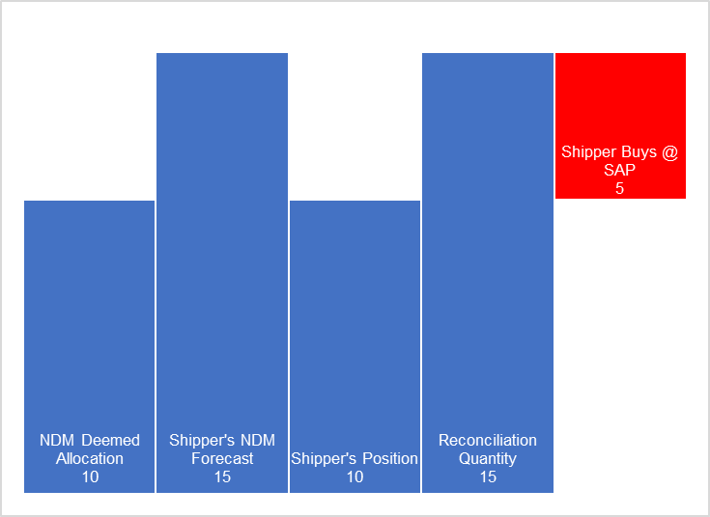
- An initial NDM Deemed Allocation is calculated by Xoserve using the forecasting alogorithm
- The Shipper creates their own forecast and believes they will require more than the Deemed Allocation
- The Shipper acquires and contracts as per the NDM Deemed Allocation
- There is no difference between the Shipper’s contracted volume and the NDM Deemed Allocation, therefore no Imbalance payment is made.
- Meter Reads are submitted and a Daily Reconcliation Quantity is calculated
- The reconciliation quantity shows the Shipper’s own forecast was correct
- The Shipper Buys the Reconciliation quantity at System Average Price
Example Two- For Information Only
The example below shows the current processes if a Shipper were to contract above their NDM Deemed Allocation. Submission of Reconciliation metered volumes shows this volume forecast to be accurate, however the use of SMP and SAP at distinct stages results in a monetary loss to the Shipper.

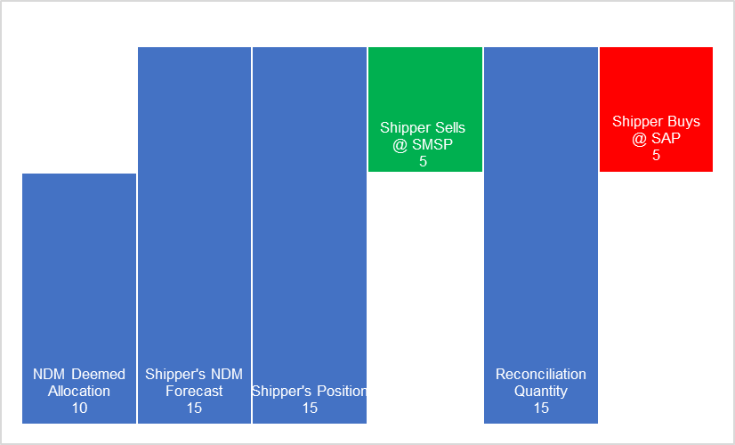
- An initial NDM Deemed Allocation is calculated by Xoserve using the forecasting alogorithm
- The Shipper creates their own forecast and believes they will require more gas than the NDM Deemed Allocation suggests
- The Shipper contracts volume as per their own Forecast
- The Imbalance process results in the Shipper being cashed out to their initial NDM Deemed Allocation level. In this example the Shipper is “long” and therefore sells the volume difference at System Marginal Sell Price.
- Meter Reads are submitted and a Daily Reconcliation Quantity is calculated. The reconciliation quantity shows the Shipper’s own forecast was correct.
- The reconciliation quantity is the same volume as sold during the Imbalance process, however the Shipper must pay at SAP.
This means that two separate payments have been made:
- The difference between the NDM Deemed Allocation and the Shipper’s Position, paid to the Shipper at SMSP.
- The difference between the NDM Deemed Allocation and the final Reconcilition Quantity, paid by the Shipper at SAP.

 | kWh | p/kWh | Cost
NDM Deemed Allocation | 10
Shipper's NDM Forecast | 15
Shipper’s Position | 15
Shipper Sells @ SMSP | 5 | 1.4 | 7
Reconciliation Quantity | 15
Shipper Buys @ SAP | -5 | 1.5 | -7.5
Differential |  |  | -0.5
In this example, as a result of the Shipper’s accurate forecast, the volumes settled in each process are equal but opposite. However, the Shipper takes a financial hit equal to the difference between SMSP and SAP multiplied by the reconciled volume.
Example Three- For Information Only
The example below shows the current processes if a Shipper were to submit a forecast below their NDM Deemed Allocation. Submission of Reconciliation metered volumes shows this volume forecast to be accurate, however the use of SMP and SAP results in a monetary loss to the Shipper.

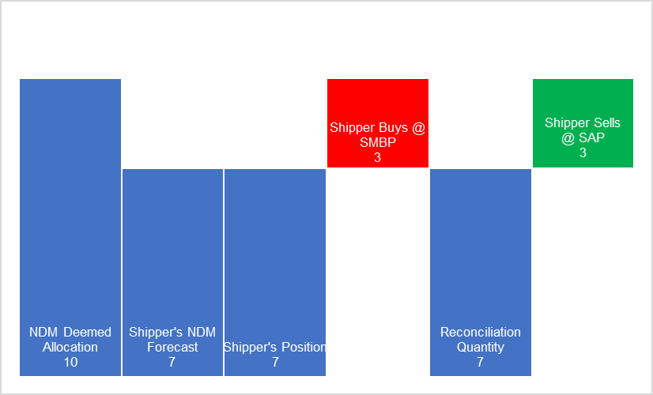
- An initial NDM Deemed Allocation is calculated by Xoserve using the forecasting alogorithm
- The Shipper creates their own forecast and believes they will require less gas than the NDM Deemed Allocation suggests
- The Shipper acquires and Nominates volume as per their own Forecast
- The Imbalance process results in the Shipper being cashed out to their initial NDM Deemed Allocation level. In this example the Shipper is “short” and therefore Buys at SMBP.
- Meter Reads are submitted and a Daily Reconcliation Quantity is calculated. The reconciliation quantity shows the Shipper’s own forecast was correct.
The reconciliation quantity is the exact same volume as paid out as a result of the Imbalance process, however here the Shipper Sells at SAP.
 | kWh | p/kWh | Cost
NDM Deemed Allocation | 10
Shipper's NDM Forecast | 7
Shipper’s Position | 7
Shipper Buys @ SMBP | -3 | 1.6 | -4.8
Reconciliation Quantity | 7
Shipper Sells @ SAP | 3 | 1.5 | 4.5
Differential |  |  | -0.3

Materiality
Analysis has been undertaken to provide context and an indication of the materiality of the issue which our proposal seeks to address. The following analysis should give a feel for the risk introduced by using actual system prices (SSP/SBP vs SAP) for the Imbalance and Reconciliation processes.
851 days worth of system price and volume allocation data has been gathered from National Grid’s Transmission operational data (http://mip-prod-web.azurewebsites.net/DataItemExplorer/Index). System Average, Buy and Sell prices are all taken from National Grid and are the actual system prices for each date. The allocation data is also real data and represents the total amount of gas allocation (in kTh) for each given date (converted from Grid’s kWh value at the standard 29.3071 kWh/therm).
Two theoretical market participants’ processes have been constructed, a Small Shipper and a Large Shipper. The Small Shipper has a 1% market share and the Large Shipper has a 15% market share, for the purposes of our model these percentages equate to a share of the total allocation, as provided by the National Grid data. Building further upon this, three reconciliation scenarios for each Shipper were constructed: a 1%, 5% and 10% reconciliation run. To calculate the risk introduced, the maximum absolute variance between SBP-SAP and SSP-SAP is taken. This variance represents the theoretical maximum impact the use of SSP/SBP for one process and SAP for another could have.
This maximum absolute variance is then multiplied by the total allocation for the day, to create a theoretical maximum impact of the issue across the entire market. This maximum is then apportioned based on the market share assigned to the Large and Small Shipper. Finally, this value is then broken down into various potential reconciliation quantities to give a feel for a potential impact. This then produces a maximum value for each reconciliation scenario on each date.

The results are summaried in the table below. An average monthly risk has been calculated by taking an average across every day (851 days) of results and multiplying this by 30.5 (average no. days in a month) to give a feel for average monthly risk. The results are provided in the table below. The full set of data and analysis is included as Appendix C: Imbalance Reconciliation Materiality Data

Average Monthly Risk
Large Shipper - 1% Reconciled | £84,324
Large Shipper - 5% Reconciled | £421,622
Large Shipper - 10% Reconciled | £843,245
Small Shipper- 1% Reconciled | £5,622
Small Shipper - 5% Reconciled | £28,108
Small Shipper - 10% Reconciled | £56,216

- Appendix B – Potential Solutions
Below are the solutions explored and identified during the development of this proposal.
Solution A proposes using SMPB and SMPS for the reconciliation calculations.
Solution A2 proposes using SAP for all imbalance prices, i.e. both the reconciliation calculations and the imbalance calculations.
Solution B proposes to make SMPB and SMPS the same. This would make it the same as the electricity model
Solution C proposes to introduce a new process after the reconciliation process to balance the books using SMPB and SMPS. This is similar to Solution A but does not happen in real time but after the event.
Worked Examples - For Information Only
Solution A – Worked Examples – For Information Only
Solution A Scenario A – Shipper Purchases above NDM Deemed Allocation

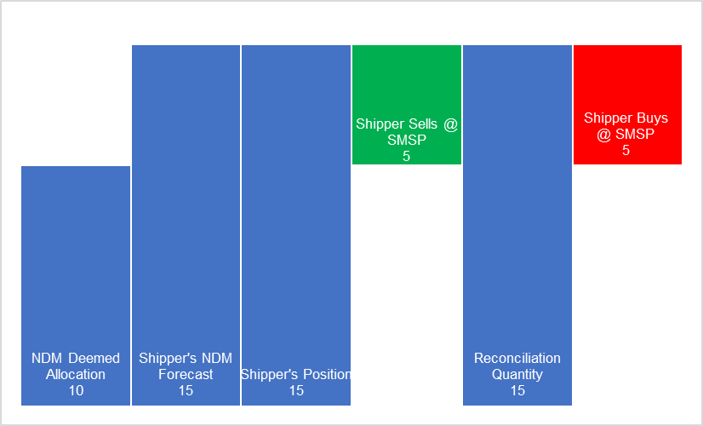
In the diagram above the Shipper is cost neutral for the gas it purchased in advance of the Gas Day.
- The NDM Deemed Allocation is produced by Xoserve using the forecasting algorithm
- The Shipper creates their own forecast and believes they will require more gas than the NDM Deemed Allocation suggests
- The Shipper acquires and Nominates volume as per their own Forecast
- The Imbalance process results in the Shipper being cashed out to their initial NDM Deemed Allocation level. In this example the Shipper is “long” and therefore Sells at SMSP.
- Meter Reads are submitted and a Daily Reconcliation Quantity is calculated. The reconciliation quantity shows the Shipper’s own forecast was correct.
- The reconciliation quantity is the exact same volume as paid out as a result of the Imbalance process. The shipper Buys at SMSP.
 | kWh | p/kWh | Cost
NDM Deemed Allocation | 10
Shipper's NDM Forecast | 15
Shipper’s Position | 15
Shipper Sells @ SMSP | 5 | 1.4 | 7
Reconciliation Quantity | 15
Shipper Buys @ SMSP | -5 | 1.4 | -7
Differential |  |  | 0

Solution A Scenario B – Shipper Purchases above NDM Deemed Allocation but below Reconciled Usage – For Information Only

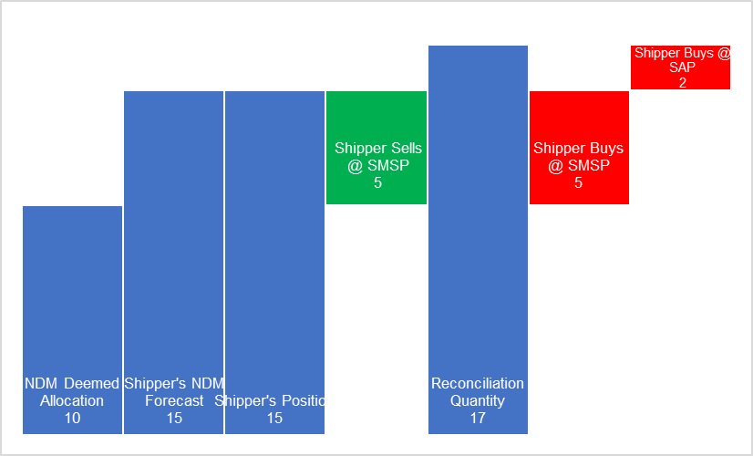
In the graph above the Shipper is not punished for purchasing above the NDM Deemed Allocation however they are still penalised for underforecasting.
- The NDM Deemed Allocation is produced by Xoserve using the forecasting algorithm
- The Shipper creates their own forecast and believes they will require more gas than the NDM Deemed Allocation suggests
- The Shipper acquires and Nominates volume as per their own Forecast
- The Imbalance process always results in the Shipper being cashed out back to their initial NDM Deemed Allocation level. In this example the Shipper is “long” and therefore Sells SMSP.
- Meter Reads are submitted and a Daily Reconcliation Quantity is calculated. The reconciliation quantity shows the Shipper’s own forecast was too low.
- The reconciliation quantity is the higher than the volume as paid out as a result of the Imbalance process. The shipper Buys SMSP up to the level of their submitted NDM Nomination. The volume above that forecasted by the Shipper is paid by them at SAP.
 | kWh | p/kWh | Cost
NDM Deemed Allocation | 10
Shipper's NDM Forecast | 15
Shipper’s Position | 15
Shipper Sells @ SMSP | 5 | 1.4 | 7
Reconciliation Quantity | 17
Shipper Buys @ SMSP | -5 | 1.4 | -7
 |  |  | 0
Shipper Buys @ SAP | -2 | 1.5 | -3
Differential |  |  | -3

Solution A Scenario C – Shipper Purchases above NDM Deemed Allocation but Reconciled Usage is in-between – For Information Only

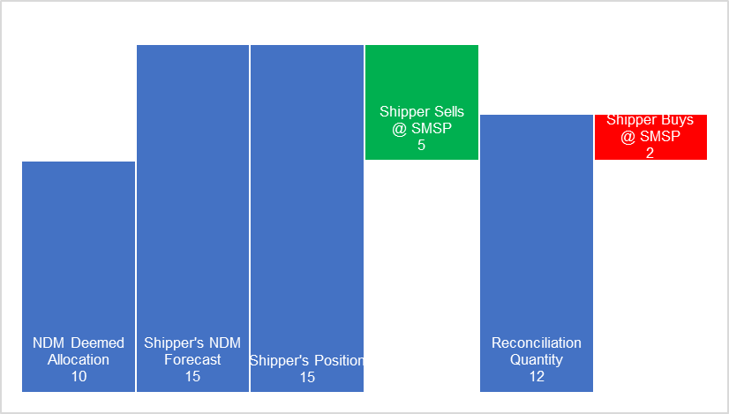
In the diagram above the Shipper is penalised for over purchasing gas but not penalised for purchasing more gas than the National Grid forecast.
- The NDM Deemed Allocation is produced by Xoserve using the forecasting algorithm
- The Shipper creates their own forecast and believes they will require more gas than the NDM Deemed Allocation suggests
- The Shipper acquires and Nominates volume as per their own Forecast
- The Imbalance process always results in the Shipper being cashed out back to their initial NDM Deemed Allocation level. In this example the Shipper is long and therefore Sells at SMSP.
- Meter Reads are submitted and a Daily Reconcliation Quantity is calculated. The reconciliation quantity shows the Shipper’s own forecast was too high.
- The reconciliation quantity is the lower than the volume as paid out as a result of the Imbalance process but higher than the NDM Deemed Allocation. The shipper Buys at SMSP up to the Reconciliation Quanity
 | kWh | p/kWh | Cost
NDM Deemed Allocation | 10
Shipper's NDM Forecast | 15
Shipper’s Position | 15
Shipper Sells @ SMSP | 5 | 1.4 | 7
Reconciliation Quantity | 12
Shipper Buys @ SMSP | -2 | 1.4 | -2.8
Differential |  |  | 4.2

Solution A Scenario D – Shipper Purchases Below NDM Deemed Allocation – For Information Only
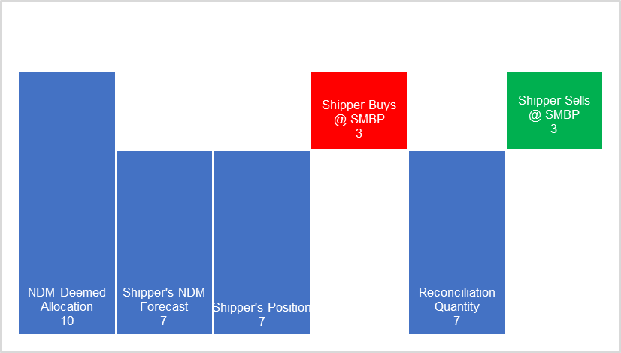
In the diagram above the Shipper is penalised for under purchasing gas but not penalised for purchasing less gas than the National Grid forecast.
- The NDM Deemed Allocation is produced by Xoserve using the forecasting algorithm
- The Shipper creates their own forecast and believes they will require less gas than the NDM Deemed Allocation suggests
- The Shipper acquires and Nominates volume as per their own Forecast
- The Imbalance process always results in the Shipper being cashed out back to their initial NDM Deemed Allocation level. In this example the Shipper is short and therefore must pay at SMBP.
- Meter Reads are submitted and a Daily Reconcliation Quantity is calculated. The reconciliation quantity shows the Shipper’s own forecast was correct.
- The reconciliation quantity is the same as the Shipper’s own NDM forecast and their initial submitted nomination. The shipper Sells SMBP.
 | kWh | p/kWh | Cost
NDM Deemed Allocation | 10
Shipper's NDM Forecast | 7
Shipper’s Position | 7
Shipper Buys @ SMBP | -3 | 1.6 | -4.8
Reconciliation Quantity | 7
Shipper Sells @ SMBP | 3 | 1.6 | 4.8
Differential |  |  | 0

Solution A2 – Adjust Imbalance Payments to be made at SAP
This solution proposes that all Imbalance payments are made at SAP (regardless of whether the Shipper is long/short or has over/under forecasted.) This would be a slightly less punitive model than Solution A1.
Solution A2 – Worked Examples – For Information Only
Solution A2 Scenario A – Shipper Purchases above NDM Deemed Allocation – For Information Only

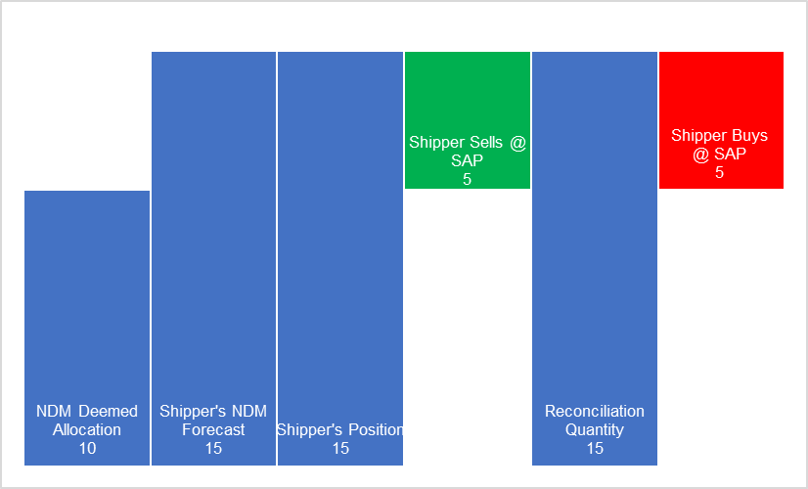
In the diagram above the Shipper is cost neutral for the gas it purchased in advance of the Gas Day.
- The NDM Deemed Allocation is produced by Xoserve using the forecasting algorithm
- The Shipper creates their own forecast and believes they will require more gas than the NDM Deemed Allocation suggests
- The Shipper acquires and Nominates volume as per their own Forecast
- The Imbalance process results in the Shipper being cashed out to their initial NDM Deemed Allocation level. In this example the Shipper is “long” and therefore Sells at SAP.
- Meter Reads are submitted and a Daily Reconcliation Quantity is calculated. The reconciliation quantity shows the Shipper’s own forecast was correct.
- The reconciliation quantity is the exact same volume as paid out as a result of the Imbalance process. The shipper Buys at SAP.
 | kWh | p/kWh | Cost
NDM Deemed Allocation | 10
Shipper's NDM Forecast | 15
Shipper’s Position | 15
Shipper Sells @ SAP | 5 | 1.5 | 7.5
Reconciliation Quantity | 15
Shipper Buys @ SAP | -5 | 1.5 | -7.5
Differential |  |  | 0

Solution A2 Scenario B – Shipper Purchases above NDM Deemed Allocation but below Reconciled Usage – For Information Only

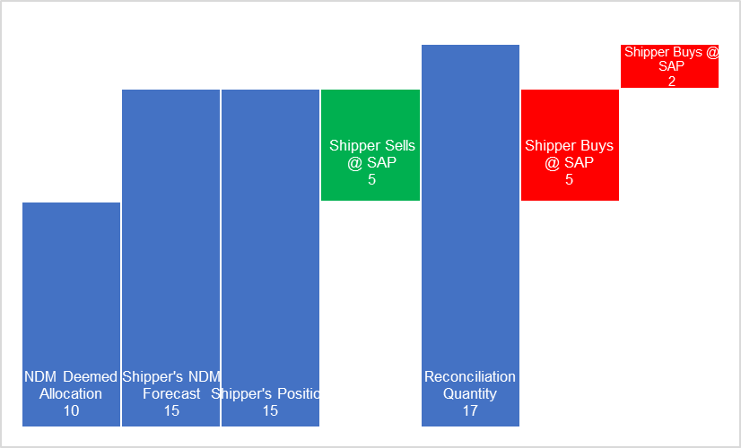
In the graph above the Shipper is not punished for purchasing above the NDM Deemed Allocation however they are still penalised for underforecasting.
- The NDM Deemed Allocation is produced by Xoserve using the forecasting algorithm
- The Shipper creates their own forecast and believes they will require more gas than the NDM Deemed Allocation suggests
- The Shipper acquires and Nominates volume as per their own Forecast
- The Imbalance process always results in the Shipper being cashed out back to their initial NDM Deemed Allocation level. In this example the Shipper is “long” and therefore Sells SAP.
- Meter Reads are submitted and a Daily Reconcliation Quantity is calculated. The reconciliation quantity shows the Shipper’s own forecast was too low.
- The reconciliation quantity is the higher than the volume as paid out as a result of the Imbalance process. The Shipper buys all of the volume at SAP.
 | kWh | p/kWh | Cost
NDM Deemed Allocation | 10
Shipper's NDM Forecast | 15
Shipper’s Position | 15
Shipper Sells @ SAP | 5 | 1.5 | 7.5
Reconciliation Quantity | 17
Shipper Buys @ SAP | -5 | 1.5 | -7.5
Shipper Buys @ SAP | -2 | 1.5 | -3
Differential |  |  | -3

Solution A2 Scenario C – Shipper Purchases above NDM Deemed Allocation but Reconciled Usage is in-between – For Information Only

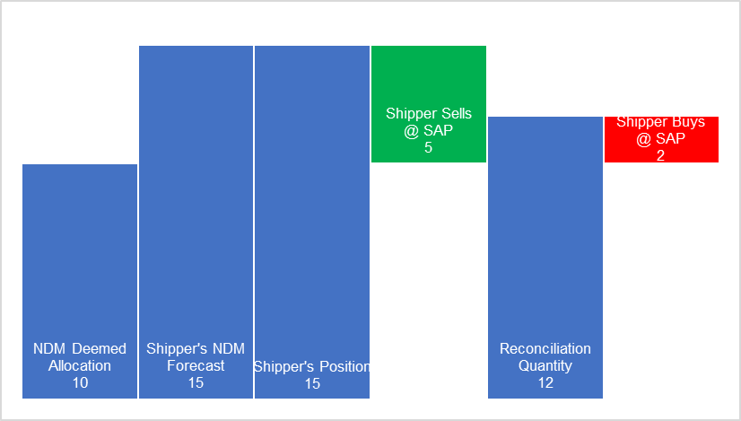
In the diagram above the Shipper is penalised for over purchasing gas but not penalised for purchasing more gas than the National Grid forecast.
- The NDM Deemed Allocation is produced by Xoserve using the forecasting algorithm
- The Shipper creates their own forecast and believes they will require more gas than the NDM Deemed Allocation suggests
- The Shipper acquires and Nominates volume as per their own Forecast
- The Imbalance process always results in the Shipper being cashed out back to their initial NDM Deemed Allocation level. In this example the Shipper is long and therefore Sells at SAP.
- Meter Reads are submitted and a Daily Reconcliation Quantity is calculated. The reconciliation quantity shows the Shipper’s own forecast was too high.
- The reconciliation quantity is the lower than the volume as paid out as a result of the Imbalance process but higher than the NDM Deemed Allocation. The shipper Buys at SAP up to the Reconciliation Quanity
 | kWh | p/kWh | Cost
NDM Deemed Allocation | 10
Shipper's NDM Forecast | 15
Shipper’s Position | 15
Shipper Sells @ SAP | 5 | 1.5 | 7.5
Reconciliation Quantity | 12
Shipper Buys @ SAP | -2 | 1.5 | -3
Differential |  |  | 4.5

Solution A2 Scenario D – Shipper Purchases Below NDM Deemed Allocation – For Information Only

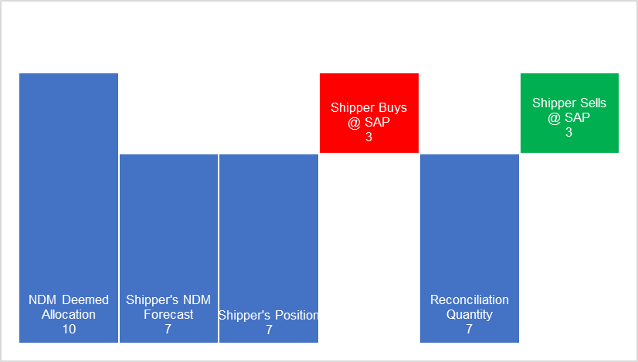
In the diagram above the Shipper is penalised for under purchasing gas but not penalised for purchasing less gas than the National Grid forecast.
- The NDM Deemed Allocation is produced by Xoserve using the forecasting algorithm
- The Shipper creates their own forecast and believes they will require less gas than the NDM Deemed Allocation suggests
- The Shipper acquires and Nominates volume as per their own Forecast
- The Imbalance process always results in the Shipper being cashed out back to their initial NDM Deemed Allocation level. In this example the Shipper is short and therefore must pay at SAP.
- Meter Reads are submitted and a Daily Reconcliation Quantity is calculated. The reconciliation quantity shows the Shipper’s own forecast was correct.
- The reconciliation quantity is the same as the Shipper’s own NDM forecast and their initial submitted nomination. The shipper Sells at SAP.
 | kWh | p/kWh | Cost
NDM Deemed Allocation | 10
Shipper's NDM Forecast | 7
Shipper’s Position | 7
Shipper Buys @ SAP | -3 | 1.5 | -4.5
Reconciliation Quantity | 7
Shipper Sells @ SAP | 3 | 1.5 | 4.5
Differential |  |  | 0

Solution B – Mirror Electricity Settlement/Imbalance Arrangements and set SBP equal to SSP within each Settlement Period
This solution would seek to mirror the Electricity imbalance arrangements and seek to set a single marginal price for all transactions based on the net imbalance of the system.
- When the system as a whole is short, take the current SBP as the single cash out price
- When the system as a whole is long, take the current SSP as the single cash out price.
This solution provides a greater incentive for Shippers to balance their own position but it will result in a more volatile cash out price. It is believed that this solution would have the greatest impact on the gas market, as it would introduce a new set of incentives to market participants.
For the purposes of this solution it is envisaged a settlement period being one gas day.
Legal Text to be developed through workgroup development.
Solution B – Example One – For Information Only
In this example, the entire gas system is short, therefore all transactions are made at SMBP.

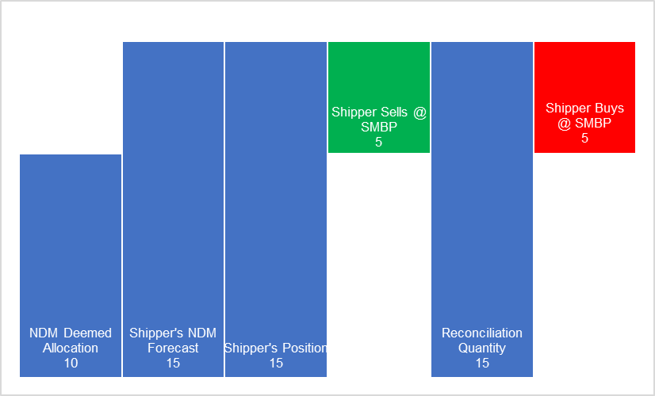
- The NDM Deemed Allocation is produced by Xoserve using the forecasting algorithm
- The Shipper creates their own forecast and believes they will require more gas than the NDM Deemed Allocation suggests
- The Shipper acquires and Nominates volume as per their own Forecast
- The Imbalance process results in the Shipper being cashed out to their initial NDM Deemed Allocation level. In this example the entire system is short, therefore the shipper sells at SMBP.
- Meter Reads are submitted and a Daily Reconcliation Quantity is calculated. The reconciliation quantity shows the Shipper’s own forecast was correct.
- The reconciliation quantity is the exact same volume as paid out as a result of the Imbalance process. The shipper Buys at SMBP.

 | kWh | p/kWh | Cost
NDM Deemed Allocation | 10
Shipper's NDM Forecast | 15
Shipper’s Position | 15
Shipper Sells @ SMBP | 5 | 1.6 | 8
Reconciliation Quantity | 15
Shipper Buys @ SMBP | -5 | 1.6 | -8
Differential |  |  | 0

Solution B – Example 2 – For Information Only
In this example, the entire gas system is long, therefore all transactions are made at SMSP.

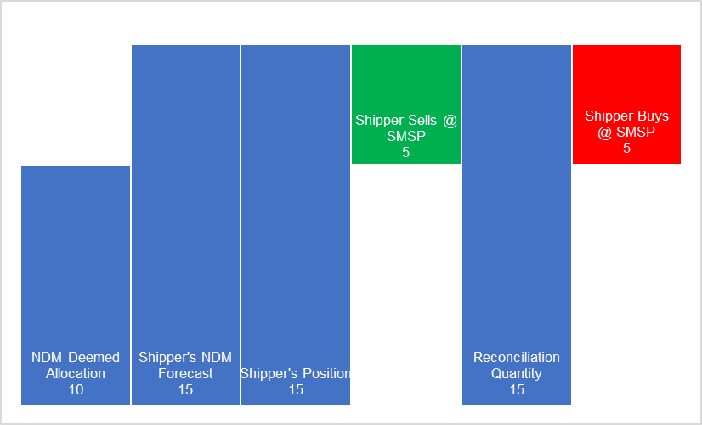
- The NDM Deemed Allocation is produced by Xoserve using the forecasting algorithm
- The Shipper creates their own forecast and believes they will require more gas than the NDM Deemed Allocation suggests
- The Shipper acquires and Nominates volume as per their own Forecast
- The Imbalance process results in the Shipper being cashed out to their initial NDM Deemed Allocation level. In this example the entire system is “long” and therefore the Shipper sells at SMSP.
- Meter Reads are submitted and a Daily Reconcliation Quantity is calculated. The reconciliation quantity shows the Shipper’s own forecast was correct.
- The reconciliation quantity is the exact same volume as paid out as a result of the Imbalance process. The shipper Buys at SMSP.
 | kWh | p/kWh | Cost
NDM Deemed Allocation | 10
Shipper's NDM Forecast | 15
Shipper’s Position | 15
Shipper Sells @ SMSP | 5 | 1.4 | 7
Reconciliation Quantity | 15
Shipper Buys @ SMSP | -5 | 1.4 | -7
Differential |  |  | 0

Solution C - Imbalance Reconciliation Process
This solution would see no changes to the existing Imbalance and Reconciliation processes.
A new process could be introduced which would calculate a credit or debit to the Shipper:
- Take the Shipper’s Imbalance Quantity and the SMP at which the imbalance was cashed-out (SMPB or SMPS)
- Take the Shipper’s Reconciliation Quantity and Imbalance Quantity. Provided both are in the same direction (long/short) then take the lower of the two quantities as the Imbalance Reconciliation Quantity.
- Calculate the difference between the applicable SMP and SAP
- Multiply the difference between the Reconciliation Quantity and the Imbalance Quantity by the price differential between SMP and SAP

There would be no anticipated changes required to the following processes:
- Daily energy imbalance
  - SMP Buy/Sell used for energy imbalance calculation
  - Daily energy imbalance (closed-out) position – not updated as a consequence of meter point reconciliation
- UIG (charged at SAP)
- Meter point reconciliation charged at SAP
This solution requires no changes to any of the processes above yet incentivises shippers to forecast accurately.

Legal text to be developed through workgroup development.
Solution C – Example One – For Information Only

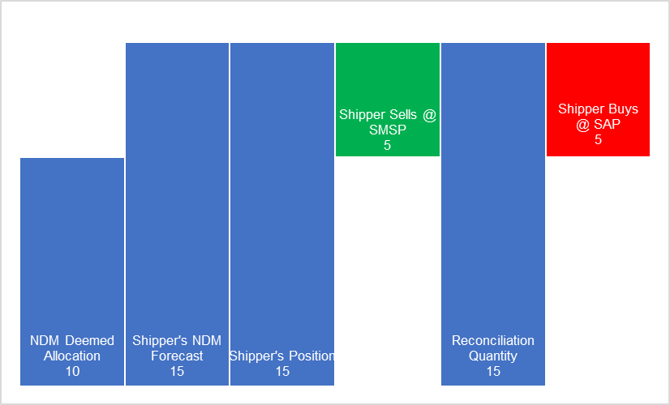
The existing Imbalance and Reconciliation processes would still occur, as in current arrangements:
- An initial NDM Deemed Allocation is calculated by Xoserve using the forecasting alogorithm
- The Shipper creates their own forecast and believes they will require more gas than the NDM Deemed Allocation suggests
- The Shipper contracts volume as per their own Forecast
- The Imbalance process results in the Shipper being cashed out to their initial NDM Deemed Allocation level. In this example the Shipper is “long” and therefore sells the volume difference at SMSP
- Meter Reads are submitted and a Daily Reconcliation Quantity is calculated. The reconciliation quantity shows the Shipper’s own forecast was correct.
- The reconciliation quantity is the same volume as sold during the Imbalance process, however the Shipper must pay at SAP.
 | kWh | p/kWh | Cost
NDM Deemed Allocation | 10
Shipper's NDM Forecast | 15
Shipper’s Position | 15
Shipper Sells @ SMSP | 5 | 1.4 | 7
Reconciliation Quantity | 15
Shipper Buys @ SAP | -5 | 1.5 | -7.5
Differential |  |  | -0.5
The new imbalance reconciliation process would not impact any of the existing processes and therefore the above would occur as it does under current arrangements.
Applying the New Imbalance Reconciliation Process
- Take the Shipper’s Imbalance Quantity, direction and associated system price
Shippers Imbalance Quantity = 5 Units
Associated System Price = SMSP
- Take the Shipper’s Reconciliation Quantity and associated system price
Shippers Reconciliation Quantity = 5 Units
Associated System Price = SAP
- Calculate the price differentials (between the daily SMP (buy/sell) and SAP)
System Marginal Sell Price (SMSP) = 1.4
System Average Price (SAP) = 1.5
(SAP – SMSP) = 0.1
- Calculate the Imbalance Reconciliation Quantity, using the Shipper’s Imbalance Quantity and Reconciliation Quantity:
Shipper’s Reconciliation Quantity = 5 Units
Shipper’s Imbalance Quantity = 5 Units
Therefore, Imbalance Reconciliation Quantity = 5 Units
- Multiply the Imbalance Reconciliation Quantity by the price differential:
Shipper’s Imbalance Reconciliation Quantity = 5 Units
Price Differential = 0.1
Imbalance Reconciliation Payment = 5 x 0.1 = 0.5
 | kWh | p/kWh | Cost
NDM Deemed Allocation | 10
Shipper's NDM Forecast | 15
Shipper’s Position | 15
Shipper Sells @ SMSP | 5 | 1.4 | 7
Reconciliation Quantity | 15
Shipper Buys @ SAP | -5 | 1.5 | -7.5
Differential |  |  | -0.5
Imbalance Reconciliation Quantity | 5 | 0.1 | 0.5
Outturn |  |  | 0

Solution C Example Two – For Information Only

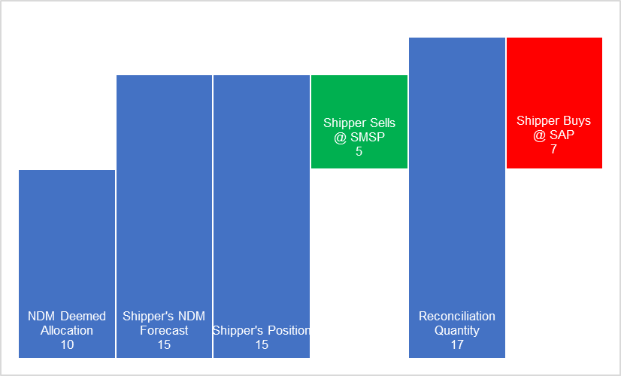
Standard Imbalance and Reconcilation Process Still Applies
- The NDM Deemed Allocation is produced by Xoserve using the forecasting algorithm
- The Shipper creates their own forecast and believes they will require more gas than the NDM Deemed Allocation suggests
- The Shipper acquires and Nominates volume as per their own Forecast
- The Imbalance process always results in the Shipper being cashed out back to their initial NDM Deemed Allocation level. In this example the Shipper is “long” and therefore Sells SMSP.
- Meter Reads are submitted and a Daily Reconcliation Quantity is calculated. The reconciliation quantity shows the Shipper’s own forecast was too low.
- The Shipper then Buys the Daily Reconcilation Quantity at SAP
 | kWh | p/kWh | Cost
NDM Deemed Allocation | 10
Shipper's NDM Forecast | 15
Shipper’s Position | 15
Shipper Sells @ SMSP | 5 | 1.4 | 7
Reconciliation Quantity | 17
Shipper Buys @ SAP | -7 | 1.5 | -10.5
Differential |  |  | -3.5
The new imbalance reconciliation process would not impact any of the existing processes and therefore the above would occur as it does under current arrangements.
Applying the New Imbalance Reconciliation Process
- Take the Shipper’s Imbalance Quantity, direction and associated system price
Shippers Imbalance Quantity = 5 Units
Associated System Price = SMSP
- Take the Shipper’s Reconciliation Quantity and associated system price
Shippers Reconciliation Quantity = 7 Units
Associated System Price = SAP
- Calculate the price differentials (between the daily SMP (buy/sell) and SAP)
System Marginal Sell Price (SMSP) = 1.4
System Average Price (SAP) = 1.5
(SAP – SMSP) = 0.1
- Calculate the Imbalance Reconciliation Quantity, using the Shipper’s Imbalance Quantity and Reconciliation Quantity:
Shipper’s Reconciliation Quantity = 7 Units
Shipper’s Imbalance Quantity = 5 Units
Therefore, Imbalance Reconciliation Quantity = 5 Units
- Multiply the Imbalance Reconciliation Quantity by the price differential:
Shipper’s Imbalance Reconciliation Quantity = 5 Units
Price Differential = 0.1
Imbalance Reconciliation Payment = 5 x 0.1 = 0.5
 | kWh | p/kWh | Cost
NDM Deemed Allocation | 10
Shipper's NDM Forecast | 15
Shipper’s Position | 15
Shipper Sells @ SMSP | 5 | 1.4 | 7
Reconciliation Quantity | 17
Shipper Buys @ SAP | -7 | 1.5 | -10.5
Differential |  |  | -3.5
Imbalance Reconciliation Quantity | 5 | 0.1 | 0.5
Outturn |  |  | -3
Here, the Shippers final outturn is equivalent to 2 units at SAP (i.e. the difference between Imbalance volumes and Reconciliation volumes at SAP, 2*1.50 = 3). This means that the Shipper is financially neutral for correctly forecasting and nominating their usage above the NDM Deemed Allocation but is still penalised as reconciliation shows they were short on the gas day.
Solution C – Example Three – For Information Only

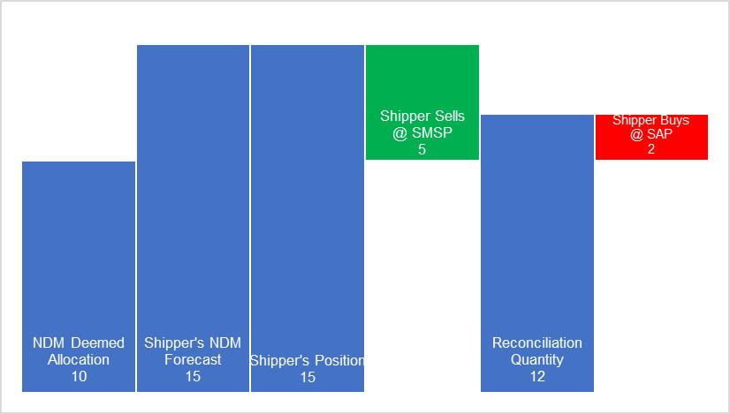
- The NDM Deemed Allocation is produced by Xoserve using the forecasting algorithm
- The Shipper creates their own forecast and believes they will require more gas than the NDM Deemed Allocation suggests
- The Shipper acquires and Nominates volume as per their own Forecast
- The Imbalance process always results in the Shipper being cashed out back to their initial NDM Deemed Allocation level. In this example the Shipper is long and therefore Sells at SMSP.
- Meter Reads are submitted and a Daily Reconcliation Quantity is calculated. The reconciliation quantity shows the Shipper’s own forecast was too low.
- The reconciliation quantity is the lower than the volume as paid out as a result of the Imbalance process but higher than the NDM Deemed Allocation. The Shipper Buys at SAP up to the Reconciliation Quanity
 | kWh | p/kWh | Cost
NDM Deemed Allocation | 10
Shipper's NDM Forecast | 15
Shipper’s Position | 15
Shipper Sells @ SMSP | 5 | 1.4 | 7
Reconciliation Quantity | 12
Shipper Buys @ SAP | -2 | 1.5 | -3
Differential |  |  | 4
The new imbalance reconciliation process would not impact any of the existing processes and therefore the above would occur as it does under current arrangements.
Applying the new Imbalance Reconciliation Process
- Take the Shipper’s Imbalance Quantity, direction and associated system price
Shippers Imbalance Quantity = 5 Units
Associated System Price = SMSP
- Take the Shipper’s Reconciliation Quantity and associated system price
Shippers Reconciliation Quantity = 2 Units
Associated System Price = SAP
- Calculate the price differentials (between the daily SMP (buy/sell) and SAP)
System Marginal Sell Price (SMSP) = 1.4
System Average Price (SAP) = 1.5
(SMSP – SAP) = 0.1
- Calculate the Imbalance Reconciliation Quantity, using the Shipper’s Imbalance Quantity and Reconciliation Quantity:
Shipper’s Reconciliation Quantity = 2 Units
Shipper’s Imbalance Quantity = 5 Units
Therefore, Imbalance Reconciliation Quantity = 2 Units
- Multiply the Imbalance Reconciliation Quantity by the price differential:
Shipper’s Imbalance Reconciliation Quantity = 2 Units
Price Differential = 0.1
Imbalance Reconciliation Payment = 2 x 0.1 = 0.2
 | kWh | p/kWh | Cost
NDM Deemed Allocation | 10
Shipper's NDM Forecast | 15
Shipper’s Position | 15
Shipper Sells @ SMSP | 5 | 1.4 | 7
Reconciliation Quantity | 12
Shipper Buys @ SAP | -2 | 1.5 | -3
Differential |  |  | 4
Imbalance Reconciliation Quantity | 2 | 0.1 | 0.2
Outturn |  |  | 4.2
Here, the Shipper’s final outturn is equivalent to 3 units at SMSP (i.e. the difference between Imbalance Quantity and Reconciliation Quantity at SMSP, 3 * 1.4 = 4.2). This means that the Shipper is financially neutral for correctly forecasting and nominating their usage above the NDM Deemed Allocation but is still penalised as reconciliation shows they were long on the gas day.

Solution C – Example Four – For Information Only

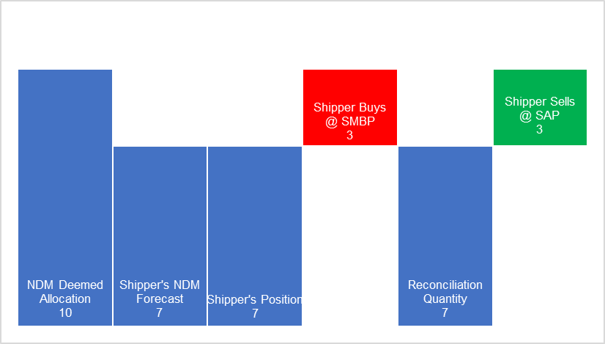
- An initial NDM Deemed Allocation is calculated by Xoserve using the forecasting alogorithm
- The Shipper creates their own forecast and believes they will require less gas than the NDM Deemed Allocation suggests
- The Shipper acquires and Nominates volume as per their own Forecast
- The Imbalance process results in the Shipper being cashed out to their initial NDM Deemed Allocation level. In this example the Shipper is “short” and therefore Buys at SMBP
- Meter Reads are submitted and a Daily Reconcliation Quantity is calculated. The reconciliation quantity shows the Shipper’s own forecast was correct
- The reconciliation quantity is the same as the Shipper’s own NDM forecast and their initial submitted nomination. The shipper Sells at SAP.
 | kWh | p/kWh | Cost
NDM Deemed Allocation | 10
Shipper's NDM Forecast | 7
Shipper’s Position | 7
Shipper Buys @ SMBP | -3 | 1.6 | -4.8
Reconciliation Quantity | 7
Shipper Sells @ SAP | 3 | 1.5 | 4.5
Differential |  |  | -0.3
The new imbalance reconciliation process would not impact any of the existing processes and therefore the above would occur as it does under current arrangements.
Applying the New Imbalance Reconciliation Process
- Take the Shipper’s Imbalance Quantity, direction and associated system price
Shippers Imbalance Quantity = 3 Units
Associated System Price = SMBP
- Take the Shipper’s Reconciliation Quantity and associated system price
Shippers Reconciliation Quantity = 3 Units
Associated System Price = SAP
- Calculate the price differentials (between the daily SMP (buy/sell) and SAP)
System Marginal Sell Price (SMBP) = 1.6
System Average Price (SAP) = 1.5
(SMBP – SAP) = 0.1
- Calculate the Imbalance Reconciliation Quantity, using the Shipper’s Imbalance Quantity and Reconciliation Quantity:
Shipper’s Reconciliation Quantity = 3 Units
Shipper’s Imbalance Quantity = 3 Units
Therefore, Imbalance Reconciliation Quantity = 3 Units
- Multiply the Imbalance Reconciliation Quantity by the price differential:
Shipper’s Imbalance Reconciliation Quantity = 3 Units
Price Differential = 0.1
Imbalance Reconciliation Payment = 3 x 0.1 = 0.3
 | kWh | p/kWh | Cost
NDM Deemed Allocation | 10
Shipper's NDM Forecast | 7
Shipper’s Position | 7
Shipper Buys @ SMBP | -3 | 1.6 | -4.8
Reconciliation Quantity | 7
Shipper Sells @ SAP | 3 | 1.5 | 4.5
Differential |  |  | -0.3
Imbalance Reconciliation Quantity | 3 | 0.1 | 0.3
Outturn |  |  | 0

Here, the Shipper’s final outturn is cost neutral. This means that the Shipper is financially neutral for correctly forecasting and nominating their usage below the NDM Deemed Allocation.

- Appendix C - Imbalance Reconciliation Materiality Data
Please refer to separate publication.

Shipper’s Position means the sum of the Shipper’s UDQIs and aggregate Trade Nomination Quantities under any Acquiring Trade Nominations, as per UNC TPD E5.1.1 (a)

