0646R OAD Review Group
Proposal for the Removal of Assets

Darren Dunkley
Cadent Gas Limited

0646R OAD Review Group

Proposal for the Removal of Assets

Version History

Version | Status | Date | Author(s) | Amendments
v0.1 | Draft | 23.07.18 | Darren Dunkley (Cadent) | Creation of draft proposal
v0.2 | Draft | 18.09.18 | Darren Dunkley (Cadent) | Inclusion of Process Flow diagram; version history & control; minor amendments to text as per 0646R meeting dated 21.08.18.
v0.3 | Draft | xx.10.18 | Darren Dunkley (Cadent) | Modification to flow diagram following review and feedback received at the September 2018 0646R Review Group.
v0.4 | Draft | 12.11.18 | Darren Dunkley (Cadent) | Further mods to flow diagram and inclusion of process steps.  Process renamed from “Redundant Assets” to “Removal of Assets”. Text updated to refrain from using site owner and site user.

Background
Under the current provisions of OAD a site user can install their assets at an offtake site providing consent is given by the site owner. Following installation, the site user then has rights to leave these deployed assets in place until a time when they decide to remove or replace them.
There are currently no provisions given to the site owner that enables them to request a site user to remove any asset residing on their land/property. OAD currently only allows such dialogue to take place when:
- a site user raises an OAD notice to cover replacement or alteration. Here, a site owner can request the assets are relocated to site users’ land but this is seen as difficult and sometimes not possible due to the location of the offtake sites, their physical configurations, and surrounding land requirements and other restrictions;
or
- when an asset is causing a clear safety issue on site. The likelihood in this scenario is that appropriate remediation and/or isolation of the asset will take place until a more permanent solution can be funded. This will then require a formal OAD notice before the permanent solution is deployed.
It is common practice between gas network operators to isolate and decommission assets when they are not needed and leave these in place providing that they do not create a process safety risk for them or another network operator. All operators consider this as a better investment decision given that the cost of removal can be significant and that such costs are ultimately passed onto consumers as part of the transportation charge.
Whilst the industry norm of abandoning assets in place is generally accepted, it is felt that the site owner should not have to bear the cost of removing site user assets when there is a clear need to do so. Any prudent operator should include the cost of asset disposal as part of their asset management system and overall strategy, and therefore for another operator to incur this cost may be construed as cross subsidisation between licensees.
There are other reasons why site users should remove assets that are no longer in use. The key ones are:
- the removal and disposal of assets should be undertaken in accordance with an operators' engineering policy and procedures, and also in line with financial accounting requirements. Some assets may still have an asset valve and these need to be treated accordingly within an operators financial accounts, especially if it will be disposed of.
- Each operator may have differing approaches and thus policies and procedures for the safe removal of assets. For one operator to remove another operators asset, this will require working on a network system for which they do not have the right competence and authorisation in terms of permitry, and if the work does not meet the required standard as a result further work and cost may have to be incurred.
- All gas network operators are affected by obsolescence. In an industry environment where grey spares are scarce to source, operators may need to refurbish and relocate assets they have in place from one site to another in order to keep their network running, or avoid a costly replacement with a different asset.

Objective
Whilst rights are currently granted to site users so that they can leave assets in place, additional clauses are required that will provide an avenue for a site owner to formally request the removal of site users assets from their land.
However, the scope of changes are to open up the code so one operator can request another operator, at a shared site, to remove an asset subject to a number of tests.
These changes are needed to provide fair and equitable arrangements for both site owners and site users in relation to removing assets, especially those that are seen to be redundant.

Proposal
An operator may request the removal of an asset, or a redundant asset when:
- an asset is causing a credible risk to the health and well-being of all staff that have to work or visit site. This includes assets that are clearly non-compliant with health & safety legislation and/or industry standards
- an asset is causing a credible risk to the safe operation of transporting gas at a site
- an asset has a credible impact upon the gas operations of another network operator
- the site owner requires the re-use of land or property, where space is of a premium and assets that are currently in place have been seen to be non-operational for 12 months or more
- any other credible and tangible risk that develops, as clearly defined and articulated by the site owner
The request must be in writing. Upon receipt the receiving party will consider the impacts of the request. They will not unwillingly delay its response to the request and will then engage with the requesting operator to seek a way forward that is equitable for both parties.
For the removal of assets where the need is based upon health, safety or operational reasons, this cost should be solely at the expense of the asset owner. For all other requests, the cost for the removing the affected assets must be identified and agreed upfront, before it is shared equally between the parties or based upon a cost benefit analysis where it is felt it is necessary.
An operator may allow another operator to remove the agreed assets on their behalf subject to the application of the required engineering governance. The cost or shared cost will then be recovered via the provisions under Section L.
Disputes are to be resolved via the appropriate escalation between parties. If this fails, the parties will seek settlement via the dispute process under the general terms of Uniform Network Code, where both parties will be bound by the outcome whether favourable or not.

Action
Operators are asked to review the proposal above taking into account the background information and the objective set, and provide feedback at the next Industry Review Group (0646R).
The intent is this document will set out the principles for addressing the issues concerning redundant assets or assets in general, so that this can then be codified under UNC OAD at a later date.

Proposed Process:

1.0 Flow Diagram
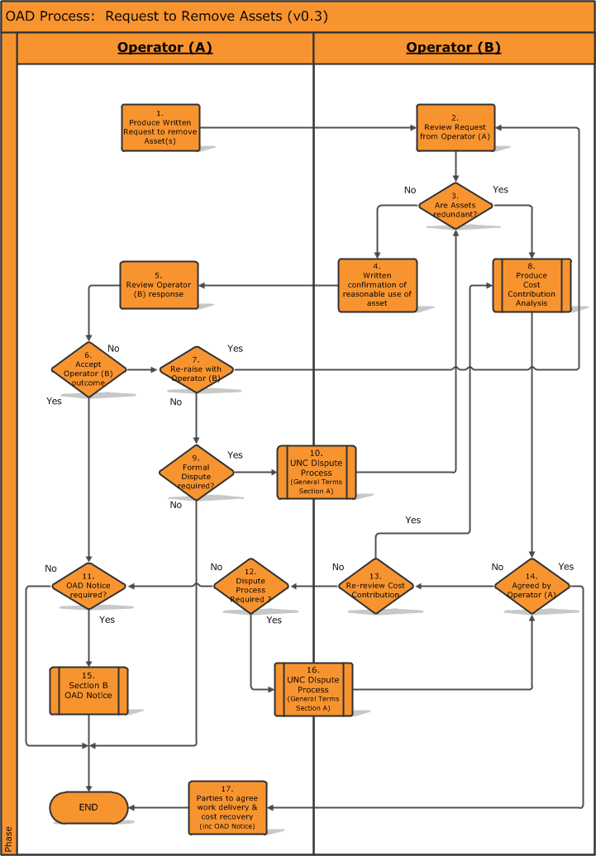

2.0 Process Steps

Step | Requirement | Owner
01 | This process enables any operator to request from another operator at a shared site, to remove an asset or assets.  The request is to be in writing outlining the specific assets that need to be removed, detailing the proposed work and the reason(s) why. | Operator A
02 | Operator B receives request from Operator A and will review accordingly. [Need SLA or timescales i.e. 60 days similar to OAD notices] | Operator B
03 | Decision Box. Operator B will check to confirm whether the assets that have been requested for removal are operational or redundant. | Operator B
04 | If the assets in question are not redundant, this must be confirmed back to Operator A in writing as such along with the supporting rationale of how they are used or will be used in the immediate future. | Operator B
05 | Operator A will review Operator B’s response to the original request. [Need SLA or timescales i.e. 60 days similar to OAD notices] | Operator A
06 | Decision Box. Following the review of Operator B’s response, Operator A will decide whether they agree with the response provided. | Operator A
07 | Decision Box. If Operator A does not agree with Operator B’s initial response or requires to explore the matter further, the parties are to engage with the appropriate dialogue until either a mutual agreement is reached or evidence of the | Operator A
08 | Operator B will produce the Cost Contribution Analysis either as it has accepted that the asset is redundant or following the outcome via the dispute process.  [NGG to provide details] | Operator B
09 | Decision Box. If all attempts have been made to resolve the matter and Operator A does not agree with Operator B’s view concerning the assets in question, then the formal disputes process may be used. | Operator A
10 | Operator A will initial the dispute process as per the requirements set in UNC – General Terms Section A.  If this process is used the parties agree to be bound by the outcome. | Operator A and B
11 | Decision Box. Operator A will consider whether it will continue with the identified work. If so, this will require the raising of an OAD Notice. | Operator A
12 | Decision Box. If all attempts have been made to resolve to seek an amicable position concerning the Cost Contribution, either Operator can seek to initiate the formal disputes process.  Again, if this process is used the parties agree to be bound by the outcome. | Operator A and B
13 | Decision Box. Does the Cost Contribution Analysis need to be revisited to find an alternative position or affirm the robustness of the original result. | Operator B
14 | Decision Box. Operator B will provide the outcome from the Cost Contribution analysis to Operator A. If the outcome is fair and equitable Operator A should accept the outcome. However, if Operator A does not agree all attempts shall be made to find the common ground and a settlement acceptable to both parties. | Operator B
15 | As the proposed work will cause an impact to both Operators, Operator A will raise the OAD notice to confirm the specific details. | Operator A
16 | Operator A will initial the dispute process as per the requirements set in UNC – General Terms Section A.  If this process is used the parties agree to be bound by the outcome. | Operator A and B
17 | Once the outcome from the Removal of Asset process is known Operator A and B will agree the proposed delivery of work, in terms of timescales and any other cost recovery to support Operator A’s work. This will include the issue of the OAD notice. | Operator A
END

END of Document

