Performance Assurance Framework - PRIDe Techniques
1 August 2018

Contents
Contents 2
About This Document 4
Roles and Responsibilities 5
Performance Assurance Framework 6
Goal 6
Principles and Objectives 7
PRIDE Scope 8
In Scope 8
Out of Scope 8
PRIDE in Gas Model 9
PRIDe Techniques 9
How can Risk be Mitigated 11
PAF Risk Register 11
PRIDe Techniques 12
Prevent 12
Detective 12
Incentive 13
Remedy 14
Education 14
Engagement 15
Evolvement 15
Summary Approach 16
Planning 16
Development 16
Implementation 16
Go live 17
Assumptions 18
Timeline 18
Reporting and Communications 19
Appendix 1 – Overview of the PRIDe in gas model 20
Appendix 2 – Overview of the Prevent technique 21
Appendix 3 – Overview of the Detect technique 22
Appendix 4 – Overview of the Incentivise technique 23
Appendix 4 – Overview of the Remedy technique 24
Appendix 5 – Overview of PRIDe in Gas Model 25

About This Document

This document summarises the Performance Assurance Framework (PAF), describes the PRIDe in Gas model, project plan for implementation of the PRIDe in Gas model, a summary of the PRIDE techniques and a toolset for the Performance Assurance Committee (PAC) to manage risk in the market.

Roles and Responsibilities
Area of Ownership | Role | Role Description
Gemserv | Performance Assurance Framework Administrator | To lead the independent development and implementation of the Performance Assurance Framework as outlined in this document. To provide confidence that the tools outlined in this document appropriately mitigated risks in the gas market
PAC | Performance Assurance Committee | Overseeing the Performance Assurance Framework. To provide direction, as required, to ensure operational integrity of the Performance Assurance Framework is maintained based on the outputs and recommendations
Xoserve | Central Data Service Provider | To assist in the delivery development and implementation of the Performance Assurance Framework and participate where necessary and required
Joint Office | Chair of PAC meetings | Chair and facilitate industry meetings including the PAC. Administering governance of the processes for modifying the UNCC.
Ofgem | Regulatory Authority | To provide direction, as required, to ensure operational integrity of the Performance Assurance Framework is maintained
Market Participants | Shippers and Transporters | Participate where necessary and required

Performance Assurance Framework

The Performance Assurance Framework is the overarching framework for the Gas Energy Settlement Performance Assurance Regime. The scheme comprises the details of the Scheme’s operation, the Performance Assurance Committee (PAC) and its operation, and the scope, operation and provision of services to be provided by the Performance Assurance Framework Administrator (PAFA). Further information of the Regime can be found in the Performance Assurance Framework Document for the (Gas) Energy Settlement Performance Assurance Scheme.

Goal
The goal of the PAF is to provide:
“A demonstrably effective settlement regime for the gas industry where no one party adversely impacts another party as a result of its failure to operate to the defined settlement regime”.

Principles and Objectives
The PAF will be guided by a set of principles that the PAC will follow when undertaking all its assurance services. These principles are that the framework will:
- Provide transparency to all stakeholders;
- Be timely, accurate and complete in the provision of the assurance services and associated toolkits;
- Be independent and impartial;
- Impose the least burden on Market Participants that is possible without compromising confidence in the assurance techniques; and
- Inspire confidence in the assurance regime.

The PAF has the following objectives:
- To determine the appropriate reporting and analysis to measure energy settlement performance and risks to it;
- To create a risk register and supporting analysis to assess risks and determine mitigation activities for energy settlement performance;
- To report as necessary; and
- To create a regime incentivising the required performance if necessary by proposing modifications to the UNC.

These objectives may be updated by the PAC from time to time as the PAF develops and evolves.

This PRIDe in gas model project plan will also adhere to a set of objectives that the work Gemserv undertakes will:

PRIDE Scope
In Scope
The PAF applies to the UNC parties that directly contribute to energy settlement performance. For the avoidance of doubt this includes all Gas Transporters, the Central Data Service Provider
and Shipper Users.

Out of Scope
The PAF is limited to energy and supply points within Local Distribution Zones (LDZ), it does not extend to energy transported through the National Transmission System and supply meter points connected to it.

PRIDE in Gas Model

The PRIDe in Gas model is based on simple, but robust, techniques.

The PRIDe in Gas model is a set of preventive, detective, incentive and remedial techniques that are supported by complementary values of education, engagement and evolution. These techniques are used flexibly to address Settlement Risks.

The PAC will be able to assess the risk to gas settlement by using reporting (the PARR), data analysis, risk management (risks defined in the PAF Risk Register) and subject matter experts and apply any techniques that are deemed appropriate to better settlement performance at a party or industry level.

The techniques of the PRIDe in Gas PAF model are to:
- Prevent the possibility of negative outcomes before they occur;
- Remedy negative outcomes through resolution processes;
- Incentivise positive actions; and
- Detect conduct that requires additional investigation.

These techniques are underpinned by a set of values which aim to set the correct behaviours:
- education: to inform and instruct parties in what is expected within the market
- engagement: to communicate with all stakeholders on a regular and informed basis
- evolution: to maintain relevance as the framework needs to adjust to changing requirements

PRIDe Techniques
The use of any techniques under this model is the decision and discretion of the PAC based on the information it receives through the PARR and the PAFA.
Technique Purpose | Techniques Description
Prevent the possibility of negative outcomes before they occur | - Monitor data for patterns proactively for both party and industry performance decline  - Educate a UNC Party (or group of parties) where reporting shows parties to be falling short of a performance standard or is impacting negatively on Settlement allocation or reconciliation  - Engage stakeholders on a regular and informed basis  - Develop processes for parties to declare adherence to obligations  - Market Entry Assessment for new entrants entering the market
Remedy negative outcomes through resolution processes | - Require a UNC Party to assess an identified performance issue and propose a resolution plan for approval by the PAC  - Require the PAFA or an industry working group to assess an industry performance issue and propose a resolution plan for approval by the PAC  - Escalation to the PAC or UNC Panel
Incentivise positive actions | - Peer comparison reporting  - Industry education sessions  - Engage stakeholders on a regular and informed basis  - Incentive Scheme (e.g. Liquidated Damages)
Detect conduct that requires additional investigation | - Performance monitoring and reporting  - Audit and investigation

The techniques described in the PRIDe model are actioned against the PAF Risk Register, where the analysis of the PARR data will support what actions the PAC and Industry are required to take.

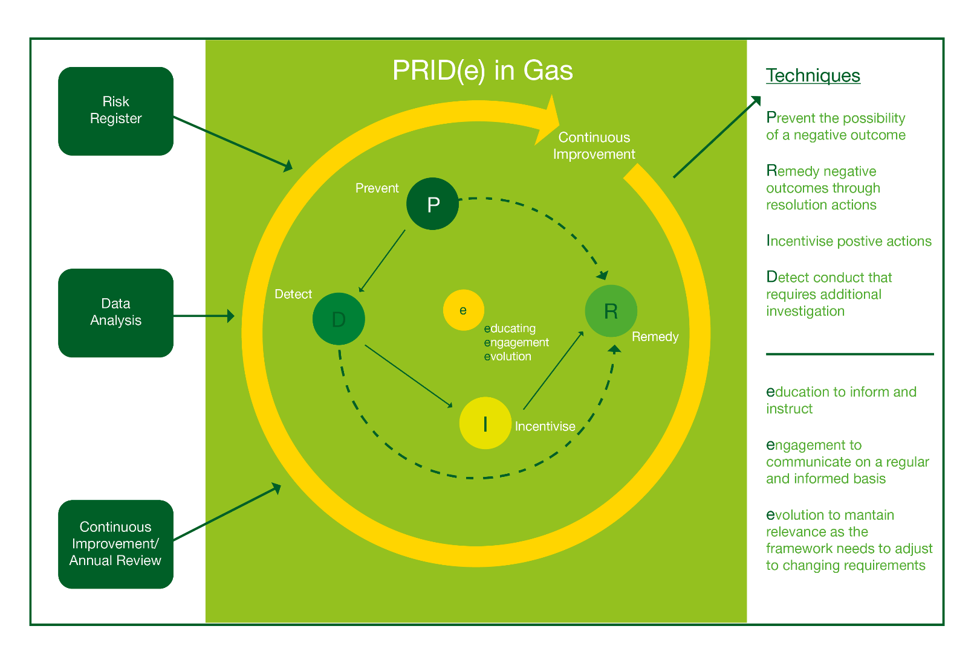

How can Risk be Mitigated

A risk can be defined as an uncertain event or set of events that, should it occur, will have an effect on the achievement of objectives. For performance assurance a risk is the probability that an event or action may adversely affect the performance and gas settlement arrangements. Settlement risks are identified in the PAF Risk Register as found on the Joint Office website.

The management of gas settlement risks through this PAF provides a process within which business critical risks can be identified, assessed, managed and reported in a visible, structured, consistent and continuous manner. Effective risk management helps to create and focus management action plans to mitigate against risk.

In order to manage risk, the PRIDe model can be used at different stages of a risk depending on the nature of the control required.

A risk that presents a significant impact to Settlement would necessitate the use of a stronger control. Whereas a risk that presents a smaller impact to settlement would necessitate the use of a weaker control. This approach allows the PRIDe model to be flexible to the nature of the risk and severity of impact to settlement.

PAF Risk Register
The PAF Risk Register sets out operational and financial risk to gas settlement. The PAF and subsequently the PAF Risk Register is limited to energy and supply points within LDZs. It does not extend to energy transported through the National Transmission System and supply meter points connected to it.

Risks within the register are valid for a PAF year, with the initial PAF Risk Register (version 2017.01) reflecting the 1 October 2017 to 30 September 2018 period.

The latest version of the Risk Register can be found on the PAC page of the Joint Office Website.

PRIDe Techniques
The sections below describe each PRIDe technique and its use.
The PRIDe in gas model operates under the assumption that all industry market participants (Gas Transporters, the Transporter Agency (or Central Data Service Provider as its successor) and Shipper Users) agree to operate within the framework, understand the framework objectives and comply with risk management actions taken within the framework.

Prevent
The Prevent technique would be used as a first course of action to consider when presented with a risk to settlement.

This technique is always used for managing risk as it contains the use of the PARR and production of performance reports to monitor market participant performance in the industry.
These performance reports are produced on a monthly basis by the PAFA and presented to the PAC at its monthly meetings with an analysis against each.

The PAC can review the information presented in the PARR reports and any additional information presented in the PAC meetings to decide on what options to take to manage performance and risk.

Options available to the PAC for prevention are:
- Continue to monitor PARR reports as standing monitoring
- Continue to monitor PARR reports for a fixed timescale before escalation decision
- Provide education to the industry
- Provide engagement to acknowledge performance
- Consider if further analysis is required on an adhoc basis
- Consider if further analysis is required on a frequent basis
- Consider Market Entry Assessment for new entrants entering the market
- Determine if current risks are being mitigated
- Determine if escalation for other techniques is required

Detective
The Detect technique would be used to investigate and audit areas of interest as recommended by the PAC.
Areas of interest can be highlighted from general PAC discussions, PAFA recommendations, other sub committees, current industry trends, industry issues and feedback from market participants.

The Detect technique can be used to investigate and create adhoc reporting for PAC’s consideration for further monitoring via inclusion in the PARR or frequent adhoc updates. This drill down analysis can be used to provide root cause analysis and determine the materiality and likelihood of new and current market risks and issues.

Areas of interest do not have to originate from performance trends highlighted using the Prevent technique or PARR reports. This will allow the PAC to discuss performance not captured in the PARR or other existing data.

The PAC would request from the CDSP data extracts for investigation into areas not captured within existing PARR reporting. These data requests can be requested by the PAC at either the PAC meetings or ex-committee. To ensure the efficient submission of data, the PAC will define a set of Service Level Agreements (SLAs) with the CDSP. The SLAs will define the method for PAC requesting data and the timescales for the CDSP to provide data.

The industry would be informed that the PAC receives non anonymised data that is contained in both the PARR and other adhoc reports via the PAC meeting minutes and meeting summary.

Options available to the PAC for detection are:
- Define and create adhoc reports as standing monitoring
- Define requirements and SLAs for CDSP data extract
- Request data analysis from PAFA
- Recommend further area of investigation
- Use prevent technique to continue monitoring standing monitoring
- Use prevent technique to continue monitoring for a fixed timescale before escalation decision
- Determine if escalation for other techniques is required
- Determine the conditions to appeal any escalation decision for incentive and remedy techniques
- Determine if current risks are being mitigated
- Determine if newly identified risks/issues are being mitigated

Incentive
The Incentive technique is used for managing persistent performance related issues and areas of high risk in the market. The technique for incentivisation would be used following the use of engagement and education.

The use of liquidated damages based on performance would be considered by the PAC at this stage depending on the significations of the issue on the market. Each identified risk in the PAR Risk Register that is being monitored either by the PARR or ad hoc report or another source would have its own discrete mechanism for incentivisation that includes performance targets and quantification for what charges would be. In activating the use of liquidated damages, the PAC would also consider the conditions for market participants to avoid liquidated damages.

The funds recovered through the use of liquidated damages should be used to educate and train market participants.

There will be an annual review of charges used for liquated damages to ensure they are appropriate.

For significant risks to the market, the industry would be informed that market participants receive non anonymised reports containing a peer comparison table based on performance via Huddle. This peer comparison or league table would identify the worst contributors in the industry for that particular list.

Options available to the PAC for incentivisation are:
- Determine if the significance of poor performance necessitates the use of liquidated damages
- Determine if the significance of poor performance necessitates the use of peer comparison tables
- Determine the conditions for entering and exiting liquidated damages
- Determine the conditions for peer comparison reporting
- Determine if escalation for other techniques is required
- Determine the conditions to appeal any decision for liquidated damages
- Determine the conditions to appeal any decision for peer comparison reporting
- Determine if performance is improving
- Determine if current risks are being mitigated

Remedy
The Remedy technique is used as a last resort once the use of other techniques that have been exhausted. The technique would be used to create and monitor a market participant’s resolution plan to improve performance.

Options available to the PAC for remediation are:
- Define and create resolution plan to improve market participant performance
- Define and create entry and exit conditions for limiting market participant operations
- Request the PAFA to monitor resolution plan and provide updates
- Determine if escalation to UNCC is required
- Determine if recommendation for expulsion from UNC is required
- Determine the conditions to appeal any decision for escalation to UNCC
- Determine the conditions to appeal any decision for expulsion from UNC

Education
The Educate value is used to inform and instruct market participants in what kind of performance is expected in the market.

This value is present throughout the PRIDe model. It underpins the need to ensure any poor performance at any escalation stage in the process is first managed by ensuring the industry understands the nature of the poor performance and so has the ability to resolve it themselves.

The PAC have the option to set the nature of industry education as well as identify who to target for education based on the performance trends of the industry.

For persistent poor performing market participants, there would be a charge for providing training and education.

Engagement
The Engagement value is used to communicate with the industry on a regular and informed basis. The need for this value is to ensure the industry is well informed on the status of risk performance and management in the market, along with their individual position and understanding of decisions made by the PAC.

The communication can take different forms including guidance documents, workshops, industry meetings, consultations and emails.

Evolvement
This value is used to ensure the framework and PRIDe model maintains relevance and adjusts to changes within the industry.

Ensuring the framework and PRIDe model remains relevant requires the need for regular review of the PRIDe model and analysis into how effective each PAC activity is to manage risk and ability to continuously improve as needed.

The PRIDe model will be reviewed on an annual basis to assess the use of the model during the previous year and the review of how effective each technique has been based on industry performance and risk scores.

The PRIDe model will also have the ability to be continuously improved and enhanced if the need arises to enable the management of future unforeseen risks.

Summary Approach
The approach can be summarised into four areas Planning, Development, Implementation and Go Live.
Planning
The planning stage includes the below tasks:
Initial PRIDe workshop
The initial PRIDe workshop will provide the PAC an opportunity to holistically review the PRIDe in gas model.
PRIDe project plan agreed
Following the initial workshop, the project plan detailing the timescales for development, implementation and go live will be agreed by the PAC.

Development
The development stage includes the below tasks:
Modification drafting
The PAC will draft the modification required to change the UNC to incorporate the PRIDe model. The PAFA will support this drafting exercise.
Incentives and liabilities workshop
The workshop will be used to define the incentives and liabilities.
Revision of PRIDe model
Following the incentives and liabilities workshop, all feedback, comments and agreements will be used to revise the PRIDe model. This revised PRIDe model will be the baselined model.

Implementation
The implementation stage includes the below tasks:
Implementation date
The implementation date follows the implementation of any changes to UNC, processes or systems.
Trial run using industry data
A trial of the PRIDe model will be used between the months of March to May 2019 to manage risk in the market. This trial will use live data provided by market participants and will assist the PAC and industry in showcasing the model before actual use.

Go live
Go live
The go live date is the agreed date when the PRIDe in gas model will be used by the PAC to manage risk in the market.

Assumptions
This section summarises the key assumptions made in developing the plan.

- PAC members are available to attend and participate in the activities described in the summary approach
- The outcomes of each workshop are progressive and progress the plan to the next stage
- Drafting of any modification is done in a timely manner
- Any modification drafted captures the PRIDe model processes accurately
- Any modification raised is progressed in a timely manner
- The industry provide representation in support of the modification
- The implementation of any changes are to the specifications detailed in the modification
- The implementation of any changes are timely managed

Timeline
Tasks | Date
Initial PRIDe workshop | 25 July 2018
PRIDe project plan agreed | August/September 2018
Revision of PRIDe model | 26 September 2018
Incentives and liabilities workshop | 26 September 2018
Revision of PRIDe model | 26 September 2018
Modification presented to PAC | 9 October 2018
Modification raised | w/c 12 November 2018
Modification process | w/c 12 November 2018 – 18 February 2019
Implementation date | 4 March 2019
Trial run using industry data | 4 March 2019 – 6 May 2019
Go live | 6 May 2019
Dates shown are indicative

Reporting and Communications
Gemserv will report to the PAC within the required timescales that will be detailed in individual PAC meetings.

Each update will cover (this list is not exhaustive and may also be changed to best reflect the requirements of the PAC):
- An overview of the project plan versus progress and delivery;
- An overview of each of the assurance techniques and its outcomes;
- Any issues or risks identified during the assurance period (and any resolution or remedial activities associated to them);
- Outstanding risks and concerns; and
- Gemserv’s (as the PAFA) opinion.

The table below summarises the frequency, methods and rationale for the regular communications between the relevant parties during the assurance process. The below description is the minimum level of activity and it is likely that further communication points will be established, dependent on need.

Who | When | What | Why | How
Ofgem | On completion of milestones  If issues arise doing development and implementation.  Final Outcome Report | Progress on the Assurance plan, execution and outcomes. | To inform the Regulator of the outcomes of the assurance technique development undertaken | By email, presentation and call (as appropriate)
PAC | Monthly at scheduled the PAC meetings and conference calls | Progress on the Assurance plan, approaches and execution. | To provide updates on progress and ensure that stakeholders are prepared appropriately | By presentation at the PAC meetings and conference calls.
Market Participants | As required | Details about the assurance processes and progress made | To enable readiness, engagement and collaboration | By call, face to face and email

Appendix 1 – Overview of the PRIDe in gas model
Appendix 2 – Overview of the Prevent technique

Appendix 3 – Overview of the Detect technique
Appendix 4 – Overview of the Incentivise technique

Appendix 4 – Overview of the Remedy technique
Appendix 5 – Overview of PRIDe in Gas Model

To find out more please contact:
Performance Assurance Framework Administrator
T: 020 7090 1001
E: PAFA@gemserv.com
W: www.gemserv.com

London Office:
8 Fenchurch Place
London
EC3M 4AJ

Company Reg. No: 4419878

