Request Report
DSC CoMC Consent for Disclosure of Information
Supplier request for access to non-portfolio data to improve the reliability of switching

Prepared by | Andy Miller
Submitted for | Decision.
Decision details | The CoMC is requested to determine whether the following proposal to disclose information to Suppliers should proceed under CoMC direction or not.  The GT and iGTs representatives at CoMC are requested to determine whether a Confidentiality Agreement is required – see section 4.  CoMC is requested approve or not this request. Note that approval is subject to the implementation of UNC modification 0649S Update to UNC to formalise the Data Enquiry Service Permissions Matrix, and iGT UNC modification 115 Update to IGT UNC to formalise the Data Permissions Matrix.
Date | 5 September 2018

- Introduction and background

Under gas and electricity governance the Joint Market Intelligence Service (MIS) Development Group (JMDG) was convened to take forward the development of MIS services to meet the Ofgem Switching Programme for improved reliability of switching.

Following industry consultation the JMDG is working through a number of use cases to identify industry change that will have a positive impact on reliability of switching. JMDG recommendations are submitted to the MIS Programme Board (MPB) for approval and sponsorship.

JMDG developed a use case to extend gas data available to Suppliers for switching purposes. This was approved by MPB and UNC modification 0663S Extending the data comprised under the definition of Supply Point Premises Data (TPD V5.18.1), and iGT UNC modification 114 Extending the data available to Suppliers under K24.3(l). These modifications have been developed and a final dataset agreed. The modifications will be withdrawn in the event of implementation of 0649S and 115.

The purpose of engagement prior to 0649S and 115 implementation is to obtain a decision at the soonest possible time.

- Data items

Suppliers already have permissions to access certain data items. The additional data being requested and their justification are shown in the table below. Note that the permitted disclosure if for all supply meter point information regardless of whether the customer is domestic or non-domestic. For information the existing data permitted for disclosure to Suppliers is shown in Appendix A.

Data item | Justification
Annual Quantity | Required to validate any consumption information provided by the consumer and to provide quotation services.
Formula Year Annual Quantity | Required to provide quotation services as the Supplier’s Shipper will be charged on this data item, so ensures Supplier quote to consumer matches expected transportation charges to Shipper.
Supply Meter Point system offtake quantity | Required to provide quotation services as the Supplier’s Shipper will be charged on this data item, so ensures Supplier quote to consumer matches expected transportation charges to Shipper.
Formula Year Supply Meter Point system offtake quantity | Required to provide quotation services as the Supplier’s Shipper will be charged on this data item, so ensures Supplier quote to consumer matches expected transportation charges to Shipper.
Meter status | Required to support customer account set-up. As the Supplier is responsible for the provision of metering services early identification that there is no meter present or the meter is clamped (or that central data is inconsistent with the physical meter) will help the Supplier to take any necessary steps and to set up the consumer record correctly.
Isolation status | This is a function of Meter Status (where one is installed or has been removed / clamped). Helpful in setting up the customer account.
Meter Asset Manager short code | Required to help the Supplier establish the correct commercial relationships for metering services.
Latest Meter Reading | Required to help the Supplier validate the opening meter reading (note: this information is provided in the MRI file to the Shipper prior to the confirmation effective date).
Meter Reading date
Meter Reading type
Automated meter reading (AMR) indicator | Required to help the Supplier establish the correct commercial relationships for meter reading services.
Automated meter reading (AMR) service provider identity. | Required to help the Supplier establish the correct commercial relationships for meter reading services.

- Privacy Impact Assessment

Where the disclosure of information includes the processing of personal data a Privacy Impact Assessment may be required.

Xoserve has considered the various tests that may be applied and considers that none of these are met and so a Privacy Impact Assessment is not required.

The tests (and answers) applied in determining whether a Privacy Impact Assessment was required were:
- Will the project involve the collection of new information about individuals?
No
- Will the project compel individuals to provide information about themselves?
No
- Will information about individuals be disclosed to organisations or people who have not previously had routine access to the information?
No, Suppliers already have access to a number of supply point information services.
- Are you using information about individuals for a purpose it is not currently used for, or in a way it is not currently used?
No
- Does the project involve you using new technology that might be perceived as being privacy intrusive? For example, the use of biometrics or facial recognition.
No
- Will the project result in you making decisions or taking action against individuals in ways that can have a significant impact on them?
No
- Is the information about individuals of a kind particularly likely to raise privacy concerns or expectations? For example, health records, criminal records or other information that people would consider to be private.
No
- Will the project require you to contact individuals in ways that they may find intrusive?
No
- Will the disclosure of information utilise new technology for Xoserve?
No.
- Will the disclosure include information that identifies a vulnerable customer?
No
- Will the disclosure release mass data to a party?
No
- Will the disclosure include information that identifies an occurrence of theft of gas.
No
- Will the disclosure require a fundamental change to Xoserve business
No

- Commercial model

This service is a commercial service. Xoserve will contract with Suppliers under a commercial contract. It is expected a Confidentiality Agreement will be required between GTs and iGTs and each Supplier to provide the GTs with control over permitted use of the data.

The contract will include a condition that data is only accessed where the Supplier has consumer consent and a right of audit of accesses made.

The commercial model is expected to look as follows:

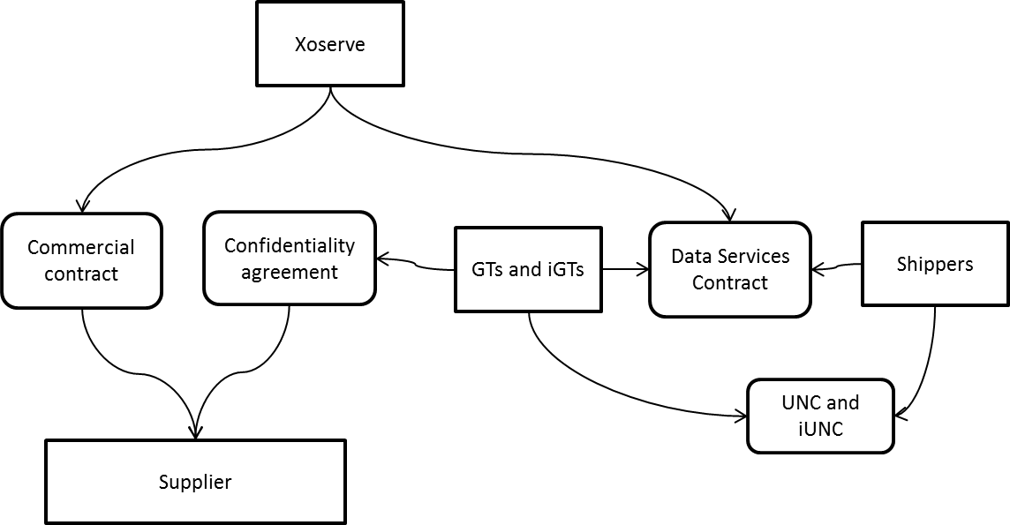

- Method of access to the dataset

Suppliers already have access to a dataset within the Data Enquiry Service. Xoserve will provide access to the full dataset (the data items in section 2, and the data items in Appendix A) via Application Programme Interface (API). The API capability enables Xoserve record each supply meter point accessed by each Supplier and to use this data to undertake audits with the Supplier to demonstrate consumer consent.

For the avoidance of doubt Xoserve will not provide access to the new data items (those in section 2) available to Suppliers by any other means e.g. telephone services, reports etc.

- CoMC determinations

CoMC is requested to approve (subject to modifications 0649S and 115 being implemented):

- The disclosure of the data in section 2 to Suppliers
- Specifically for GTs and iGTs that a Confidentiality Agreement required.
Appendix A. Existing data items already subject to permitted disclosure to Suppliers

Data Item | DES community view
Supply Meter Point Reference Number, | Y
supply point address | Y
Meter Post Code | Y
Unique property reference number | Y
Local Distribution Zone | Y
Current supplier ID | Y must accept additional terms
Incoming supplier | Y must accept additional terms
network operator | Y
Transporter identity | Y
Transporter effective from date | Y
CSEP identifier | Y
Supply Meter Point status | Y
Supply Point Withdrawal status | Y
Market Sector Code | Y
Existence of Interruption | Y
meter serial number | Y
meter mechanism code (includes Smart Meter Equipment Technical code) | Y
meter capacity | Y
Meter type | Y
Meter number of dials | Y
Meter imperial indicator | Y
Classification of Twin-Supply Meter Point | Y
Smart meter system operator identity | Y
Smart meter system operator effective from date | Y
Data Communications Company service flag | Y
Data Communications Company service flag effective from date | Y
Identity of the installing supplier of the smart meter | Y
Smart metering equipment technical specification installation date | Y
In home display installation status | Y

